Chapter 5 Project

How did military events and their events and their consequences contribute to the foundations of Canada?

Between the years of 1740-1774, many events took place that lead to the British gaining control of the colony of New France. Many of these events are considered turning points in Canadian history. (Remember that even small events can have big consequences). Your job is to create a timeline that shows these events in chronological order. Your timeline must include:

- A title (including the range of dates)

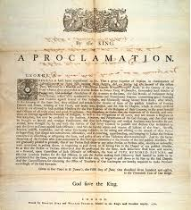
- The following events in chronological order:

  - Expulsion of the Acadians
  - Capture of Louisbourg
  - Battle of the Palins of Abraham
  - Treaty of Paris
  - Royal Proclamation
  - The Quebec Act

- For each event you must include:
  - The title of the event
  - The date(s) of the event
  - A summary of what took place (who, what, where, when & why)
  - The short term consequences
  - Long term effect you think the event had on Canada today.

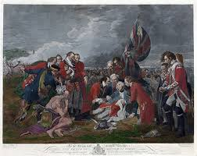
- At least 3 illustrations that depict at least three of the events that took place.

NAME:______________________________

CATEGORY | 4 | 3 | 2 | 1
Spelling and Capitalization | Spelling and capitalization were checked by another student and are correct throughout. | Spelling and capitalization were checked by another student and were mostly correct . | Spelling and capitalization were mostly correct, but were not checked by another student. | There were many spelling and capitalization errors.
Event Description  X 3 | An accurate and clear description of the event, the consequences and the long term effect has been included for each event. | A general description of the event, the consequences and the long term effect has been included for each event or some of the consequences and/or effects are missing. | An unclear description of each event has been included or some of the consequences and/or effects are missing. | The events are inaccurate and/or missing for several events, consequences and/or effects.
Graphics | All graphics are effective and correspond with at least 3 of the events. | All graphics are effective, but there appear to be too few or too many. | Some graphics are effective and their use is balanced with text use. | Several graphics are not effective.
Title | The timeline has a creative title that accurately describes the material and is easy to locate. | The timeline has an effective title that accurately describes the material and is easy to locate. | The timeline has a title that is easy to locate. | The title is missing or difficult to locate.
Dates | An accurate, complete date has been included for each event. | An accurate, complete date has been included for almost every event. | An accurate date has been included for almost every event. | Dates are inaccurate and/or missing for several events.

Total: /30

(2 marks added to the above total /28 if handed in on time)

