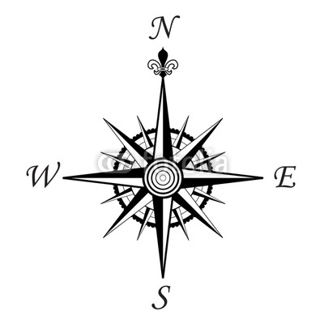
Hudson’s Bay Fur Trader - Mapping Assignment
You are a map-maker working with the Hudson’s Bay Company. Your job is to create a map that shows the locations of the major fur trading forts and cities. You must also include the vast territory that was granted by the King of England called Rupert’s Land.
- Your job is to label (try to keep all labelling horizontal and use a fine tipped black felt pen) the map with the following:

- York Factory
- Moose Factory
- Albany Factory
- Fort Garry
- Fort Whoop Up
- Rocky Mountain House
- Fort Edmonton
- Fort Resolution
- Fort Prince of Wales
- Montreal (Ville-Marie)
- Fort St. James
- Severn House

- Locate and label the territory of Rupert’s Land (see page 65 of the textbook)

- Label the following bodies of water:

- Pacific Ocean
- Atlantic Ocean
- Arctic Ocean
- Lake Huron
- Lake Ontario
- Lake Michigan
- Lake Erie
- Lake Superior
- Hudson Bay

- Label the ten provinces and three territories as they exist today

- British Columbia
- Alberta
- Saskatchewan
- Manitoba
- Ontario
- Quebec
- New Brunswick
- Nova Scotia
- Prince Edward Island
- Newfoundland
- Yukon Territory
- Northwest Territory
- Nunavut

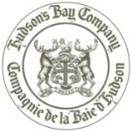
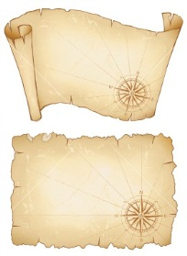
- Show the Route that the English and The French traders took to the new World and back to the home country. Use a dashed line and label it. Include a compass rose which indicates north.

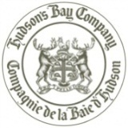
- Colour “Rupert’s Land” green, and the water blue (make sure to colour all lakes etc.). All other land should be a third colour choice. Use the techniques discussed in class to antique your map, including staining with tea, crumpling & distressing the paper, scorching the edges (only to be done with supervision of a parent)

