ELEMENTS OF A SHORT STORY

Setting:
- The time and location in which a story takes place.
- There are several aspects of a story’s setting that may contribute to a story:
  - Place – geographic location. Where is the action of the story taking place?
  - Time – When is the story taking place? (historical period, time of day, year etc.)
  - Weather Conditions – is it rainy, sunny, stormy, etc.?
  - Social Conditions – does the story take place in another culture? During a war?
  - Mood or Atmosphere – What feeling is created at the start? Is it bright/cheerful, dark/frightening, sad, etc.?
Character:
- A person in fiction. Short stories have a few characters
  - Protagonist: most important (main) character to the story; reader is generally on his or her side.
  - Antagonist: opposes the main character; creates conflict (problems, obstacles) with the protagonist.
- The characteristics or qualities of a person: In ordered for a story to seem real its characters must seem real by being: consistent, motivated and life-like.
  - Physical appearance, thinks, feels, dreams; what does the character do?
- Character Motivation: What makes a character think or act the way they do:
  - The reason characters think, feel, or act in a certain way. A character with motivation I more realistic and effective.

Conflict:
- Person vs Person:
  - The central character clashes with another person. (Doesn’t always have to be a person. Can be animals)
- Person vs Self:
  - The main character battles him or herself. (Ex: Lack of confidence)
- Person vs Society:
  - The main character challenges a law, tradition, or institution.
- Person vs Nature:
  - The main character fights to endure or overcome forces of nature.
- Person vs Supernatural:
  - The main character resists forces that are not of this world.
- Person vs Technology
  - The main character resists technological forces.

Plot:
- The plot is a planned, logical sequence of events having a beginning, middle and end.
- Short Story has only a main plot so it can be read in one sitting.
- All stories have 5 essential parts of a plot:
  - Introduction – The beginning of the story where the characters, setting, and/or situation are revealed.
  - Rising Action – Series of events move the story forward and the conflict in the story is revealed.
  - Climax – Highest point of interest and the turning point of the story. The conflict/problem is resolved?
  - Denouement (Falling Action) – Conclusion (final outcome or untangling of events in the story. Loose ends are tied up.
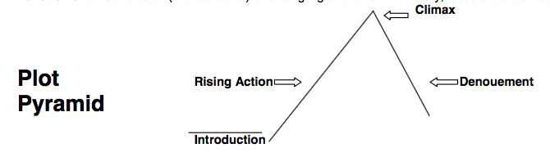

Point of View:
- The angle from which the story is told.
- First Person Point of View: the narrator (teller of the story) participates in the action of the story
  - Uses pronouns I, me, we, us
  - Reader sees the story only as the character tells it so only knows what the character knows or feels. (Need to realize the story could be biased)

- Third Person Point of View: Here the narrator does not participate in the action of the story as one of the characters, but lets us know exactly how the characters feel from outside the action.
  - Uses he, she him, her, they, them
  - We learn about the characters through this outside voice

- Omniscient Point of View: A narrator who knows everything about all the characters is all knowing, or omniscient. The author can move from character to character, event to event, having free access to the thoughts, feelings and motivations of all his characters.
  - Also uses 3rd person point of view pronouns (he, she, him, they, them)

