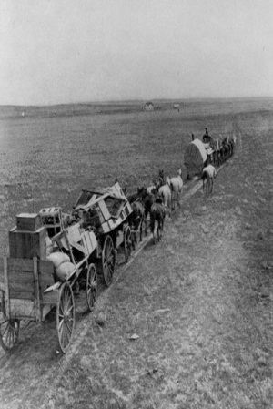
Chapter 9: Growth in the West
Name:__________________
Chapter Inquiry
How did Canada secure the West and prepare for a massive influx of immigrants?
VOCABULARY: use the glossary to define the following terms.
Natural Resources
Economy
Transcontinental Railway
Treaty
Protective Tariff
Diverse Economy

Key Concept - Natural Resources and History
Natural resources are the parts of that people can use. They include , land , furs, water, and minerals. First Nations & newcomers used these resources to meet their .
Natural Resources in Canada’s Story – Natural resources have played a role in the development of . They affected where people chose to live. Europeans first came to Canada because they were for a quicker route to . These Europeans stayed because of the of the resources.
The Importance of Land – After Confederation, thousands of newcomers began arriving in the . Most of these newcomers came because they wanted .

Securing the Land
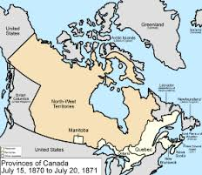
Canada wanted to its claim to the land in the West before the could it. When the Government of Canada purchased Rupert’s Land from the the region became known as the - . The government began to mark the Canada-US border.
In order to control the land the government signed _______________ with the First Nations. A new police force called the West Mounted (NWMP) was established in the West. was common and these police were expected to make the land for the new homesteaders.

Marking the Border – The parallel was the border west of the Great Lakes. In the 1870s guides, American and surveyors marked this boundary by pounding in an post every km and building a of earth every 5 kilometres.
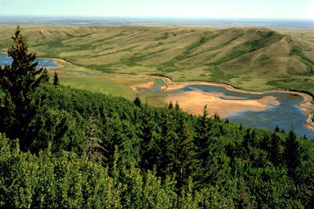
Trouble in Whoop-Up Country – In the 1860’s the Hills were known as Whoop-up . The area got its name because of U.S. traders who crossed into Canada to trade for furs and robes. Selling liquor was but no one was around to the law. Americans also came to hunt for their fur.
These “wolfers” did get along with the people very well. Why did they not get along?
______________________________________________________________________________________________________________________________________

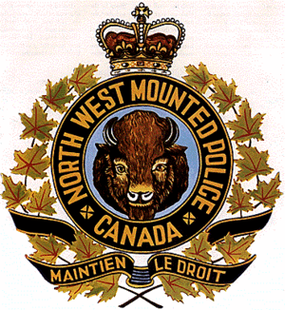
Creating a Police Force – Because of the in the area the Prime Minister decided that they needed a _____________ force.
What would the North West Mounted Police do?

A Massacre Spurs on a Prime Minister – On 1st, 1873, some First Nations were camped at a trading post in the Hills. There were some American who thought that they had their horses. In fact they hadn’t, but these wolfers them and killed as many as men, , and children. This event was known as the Cypress Hills . When Sir John A. Macdonald heard of this event he made it a to get the mounted police there as soon as .
The Great March West – In July of 300 mounted headed west. This great march did not go well and they ran on supplies, horses from a lack of and they got lost. Metis had to rescue them. Eventually they did arrive and set up Fort , Fort , Fort and Fort Calgary.

The Role of the Mounted Police – The North Mounted Police’s main role was to keep the by making sure that people the law.
What other tasks did they perform?

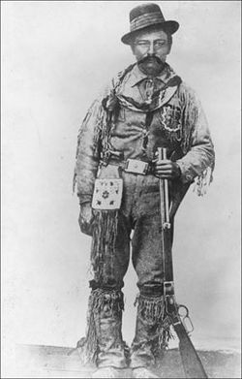
Jerry Potts (1840 – 1896) Read about Jerry Potts on page 201. Why was he so important to the N.W.M.P.?

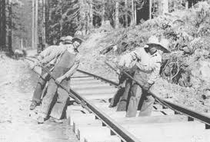
Building the Iron Road
The Prime Minister wanted a new Policy for Canada. It was called the .
A Three-Pronged Policy – To use the land effectively Canada needed three things, what were they?

How did the National Policy plan to achieve these three objectives?
- A transportation policy –
- An immigration policy –
- An economic policy –
Finding a Route – The work began on the transcontinental in the 1870s. Canada hoped that it would bring into Confederation and keep out the . Canada is a country and building the railway would be a task. To begin, surveyors had to find the route. They eventually chose the more route through Calgary and the Horse .

What were the five advantages of choosing this route?

Building the Line – A private company built the railway in . On average one kilometre of track cost dollars.
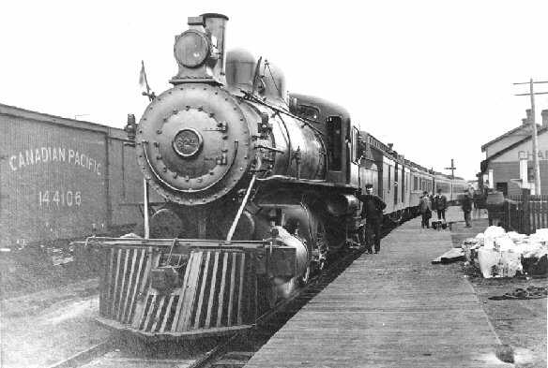
Impact of the Railway – The railway had a huge impact on the development of Canada. It brought many to the prairies.

Canada’s First Chinese Immigrants – Faced with a of workers, the CPR employed about Chinese workers to build the railway through the between 1881 and when it was completed. These Chinese labourers were paid about $ per day. Which was about of what the other workers were paid. They had to pay $ per week for room and . The work was for these workers. They were earth movers and used to blast through the . At least of these workers doing their job. Some were killed in , blown up by explosives, lost in or died of or other diseases.
Sir John A. Macdonald said “ .” Many Chinese railway workers and made Canada their home.
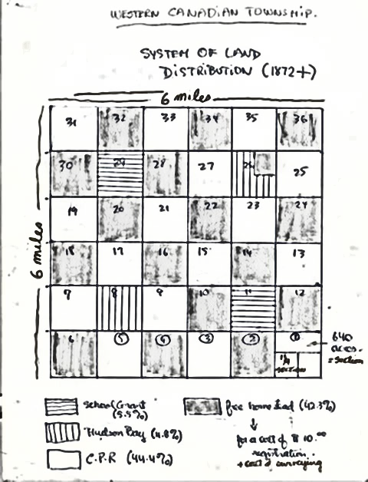
Farming the Frontier
The government needed to convince people to go west and the land.
Land Policy in the West – How did the government survey the land?
Surveyors divided the land
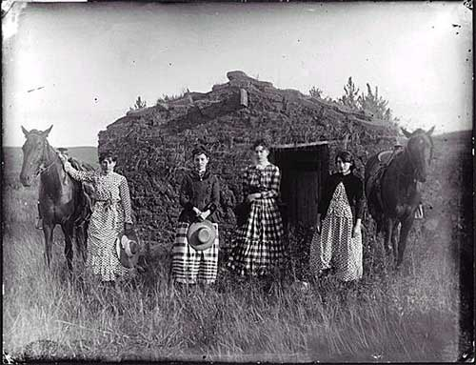
Each township was divided into 36 squares called sections. Each section was divided into quarter sections of 64 each. The surveyors drove stakes into the ground to mark the sections. All of the - Territories was measured this way. The government set aside sections in each township. These were later sold to pay for . The owned the other sections. Other sections went to the to pay for building the . The rest belonged to the new .
In 1872, the government passed the Lands Act. This act stated that any head of a family could for land. So could any who was at least years old. You could a homestead for $ .
These homesteaders had to promise to do three things. What were they?

After years, if they fulfilled these terms, they got to the land.

A Rough Life – Life as a homesteader was very . These new arrivals were poor, could not afford to buy , farm tools, or the materials to build a or barns. Crops were ruined by , lack of rain, early or . Many newcomers gave up and .

- The First Newcomers came from .
- Mennonites who came from did not believe in fighting in They were invited to move to Canada where they could practice their own and have ___________ farms. About Mennonites came.
- Another early group of immigrants came from . These were people who were fleeing a eruption. About of them arrived in 1875.

Helping Industry

The part of the National Policy was to build a strong . Colonies joined Confederation for many . One reason was to increase with one another.
What was one way of making trade possible?

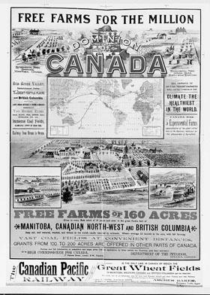
The Canadian manufacturers in the faced a huge problem. American businesses could goods in quantities. American goods were able to sell at prices than Canadian goods because their costs were .
What worried the Canadian producers? . Their worry was correct.

The Solution: Protective Tariffs - Macdonald put a on goods coming into Canada. A ____________ tariff is a tax placed on a product crossing the border and makes the product _________ expensive. Macdonald knew this would make American ________ more _________ than Canadian goods. This ensured that Canadians would the goods made in Canada.

Slow but Steady Progress – The changes in the North-West were remarkable. People came to the land. began to replace as the main export. The railroad replaced the and Red River cart as the main kind of .

The First Nations and still faced many problems. The government _________________ them. By 1891 & the North-West Territories had a population of which was more than what it had been ten years earlier. Despite this it was not the _________ growth the government had hoped for.
