Chapter 8: The Métis
Name:________________________

Chapter Inquiry – In what ways did the Métis have an impact on the development of Western Canada?
TERM | DEFINITION
Assimilation
Bill of Rights
Country Born Metis
Dempgraphics
Identity
Manitoba Act
Meatis Provisional Governement
Migration
Pemmican Proclamation
Treason
York Boats

Emerging Identities - Your identity is the set of and that you use to express who you are. Some groups may differently follow different , speak different , and hold different or points of view. These are all ways of an identity.
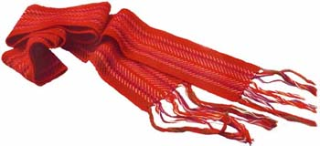
Citizenship and Identity – One result of between the First Nations and Europeans was the emergence of the . By the mid-1800s most of the Métis lived in River, Manitoba.
An Emerging Identity In The West
The children of Nations and European were called . They lived all over North America but the largest of Métis lived in Red , Manitoba which is now called .
When we examine the of the people of a particular place we are referring to the of the place. They include information such as the of people who live there, or the ratio of to female .
- How many Francophone Métis lived in the Red River region by 1840? _________
- What religion did most of them practice?
- How many non-Métis people lived in the area?
ABOUT 1000 OTHER PEOPLE LIVED NEAR RED RIVER:
- Métis were the children of First Nation women and traders from the . These Métis were usually (non-Catholics) like their fathers and also held some First Nations .
- and First Nations.
- Roman Catholic - who built churches and schools which became the centres of Métis .
- The who lived in St. .
- employees of the .

SHARED CULTURE OF THE RED RIVER METIS:
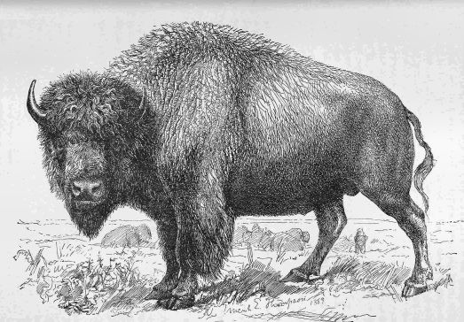
The Red River Métis shared a unique culture that their identity. They developed their own language, style, poetry, , , economy, and .
Learned several languages, including their own language called ____________.
Shared Economy – What does the word “economy” mean?
How did the Métis make a living?
The Metis in the Fur Trade: How were the Métis important to the success of the fur trade?
The Buffalo Hunt: What role did Métis play in the Buffalo Hunt?

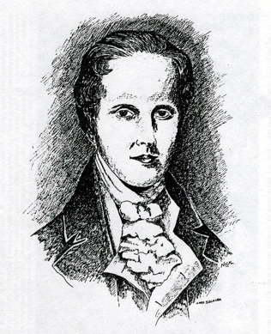
Conflict At The Red River
In the 1800s a Scottish named Lord __________ bought a huge piece of from the Hudson’s . He brought dozens of to the land from the of . He hoped that they would be able to turn the at Red River into a great colony. However the land was not and a large Métis was already established and living there.

Métis Reaction to the Colonists – The Métis had no papers that said they the land that they had been farming for more than years. They were worried that these colonist would them off their farms.
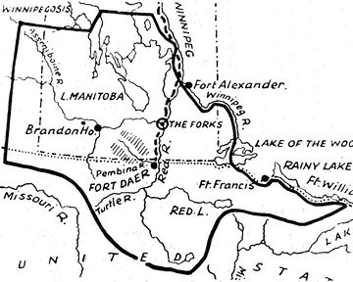
The North West Company allied with the __________ and _________ the colonie. They were competing with the _____________________ for control of the fur trade. They thought the HBC ____________ Selkirk and the colonists to ________ their trade.

Conflict over Resources – The governor was that his colonists would if all of the food was exported out of the region, so in 1814, he the Métis from exporting any , , or from the region.

What did they call this order?

The and the Red River Métis were outraged by this order because the buffalo trade was important to the Metis ________
and economy. So they tried to force the Selkirk from their area by stealing their farm , and frightening the settlers by shooting off their . As a result of these actions and a series of natural , many of the colonists .
Battle of Seven Oaks - The was between the remaining Scottish Colonists and the . The two sides faced each other near a grove of trees beside the River. A fierce fight broke out, one and Colonists were . This was the first time that the Métis stood up as a group against the Canadian . The event marked the beginning of the Métis .
Migration Further West – The Bay (owned by the British) took over the Company and with the purchase they also took over all of their lands. The began to out and the Métis hunters had to far from the Red River colony to find a . To be closer to the buffalo the Métis and settlements were set up in the provinces of and .
Red River Resistance, 1869
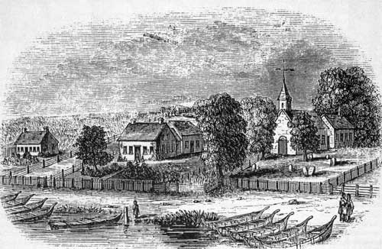
Red Métis believed that Rupert’s belonged to them.
The of Canada thought it would make a place to send colonists.The government sent scientific temas to the _________ and theuy reported that the region was well suited to , and had many resources. Outsdiers started to take notice of the west. At the same time there was a of farmland in Ontario. People began looking ousite _________ Canada for new ares to colonize, and Rupert’s ___________ looked like just the place.

Rupert’s Land Joins Canada - Some newcomers began to arrive in Red River area and the Canadian realized that if they didn’t quickly Rupert’s Land, the States would. In they purchased the territory from the Hudson’s Bay for $ million dollars.
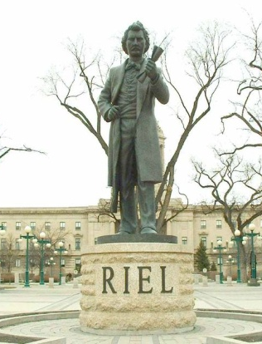
Fears of Assimilation - The Nations and living in Rupert’s Land were consulted and were uncertain about their . They were worried about which is when one culture is into another .
Red River Resistance, 1869 – Canada was ready to take
of Rupert’s Land on December 1st,
- The Federal Government sent to Red River without telling the First Nations and Métis.
- Louis Riel was a , who could speak French, and . He stopped the surveyors and told them to Red River immediately. This gave them time to how to their land
- Riel became the of the Métis Government and helped draw up a of to be presented to the Government of . This bill was meant to the interests of the different of people living in the area.

French and English Canada Take Sides – Not everyone in Red River supported the Métis . The English colonists were furious with the (French speaking) Metis. The Métis an Englishman named when he threatened to Riel. He was found and executed in front of a squad. Depending on your your reaction to this event was very different.
The Anglophone Perspective: Scott was an -speaking Protestant. His death made the population in Ontario want .
The Francophone Perspective: The Canadiens in reacted differently. They saw the Métis as of the Francophone Catholic way of .
The conflict revived the old anger between the English-speaking Protestants in Ontario & the French-speaking Roman Catholics in Quiebec. The situation threatened to become a national crisis.
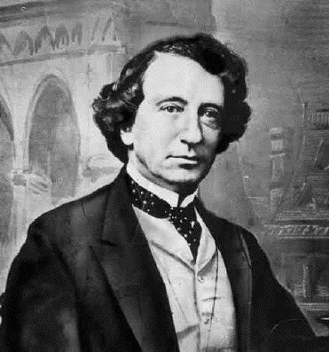
The Creation of Manitoba
Prime Minister John A wanted to find a solution to the crisis, in July the government passed the Act to try to both sides. This act would create the province in .
Some of the most important terms of the act included:
- It gave Manitoba its own government
- Both and would be spoken in the and .
- The province could send members to the House of Commons in Ottawa and members to the .
- There would be for Protestants and that would be funded.
- would be set aside for the to use.
- Natural would be under the control of the _______________ government.
Soldiers on the March – The Prime Minister sent soldiers to Red River to keep the and the area in case the States tried to it. Many of the soldiers thought they were really there to the Métis and Louis . Knowing his life was in , he to the United States. Some of the soldiers took out their on the by , jailing and them. It was a bad for the new province of .

Second Metis Uprising, 1885 - The creation of the Province of Manitoba didn’t all of the problems for the Métis and First Nations people.
Why did problems persist?

__________________________________________________________

_________________________________________________________
- ______________________________________________
Metis and First Nations Grievances – By the 1880s the Metis faced a number of challenges to their way of life, such as ______________ and _____________ that was a reslt of the reduced _____________ population.
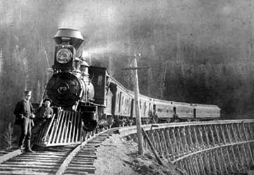
Why did the government ignore the Métis concerns?
Because they were more focused on what they thought was a more important issue which was the building of the Pacific . It was a priority because they wanted more colonists to onto the prairies and the .
RIEL RETURNS: In the summer of 1844 a group of Metis led by Garbriel Dumont went & oinvited Riel back to from the United . The Métis were and impatient that nothing was being done about their . They wanted Riel to be their . Riel and the Métis set up their own government and demanded that:

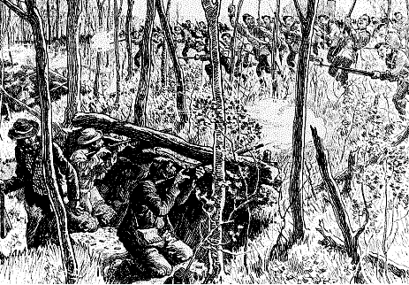
When nothing happened Riel suggested they take up a , but brief at the village of occurred. Gabriel Dumont was a strong supporter of Rield so they decided to join in the .
____________was the military general for the Métis forces. The Northwest Resistance of 1885 was violent, but brief. The federal government rushed __________ of soldiers west aboard the newly built ______________. After days of fighting, the resistance was over and the Métis .
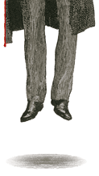
The Fate of Louis Riel - Following the Resistance, Louis Riel was accused of or the betrayal of one’s . A jury found him and Riel was sentenced to _________. Prime Minister John A. Macdonald delayed the execution because of a federal . If he sided with (the English), rather than Quebec he would likely the election.
Explain the dilemma that Prime Minister Sir John A. Macdonald found himself having to deal with by completing the following chart with information found in your textbook.
Macdonald’s Election Dilemma
The French (Quebec) | The English (Ontario)

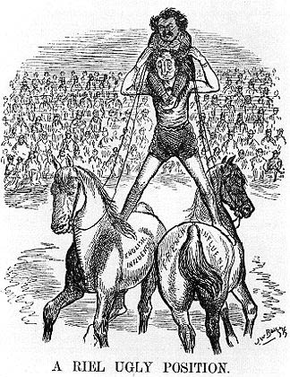
Analyze the cartoon on the left by using the Skill Check feature on page 218 of your text book. Explain the cartoon, who/what is being depicted in it? (8 Marks)

On 16th, , Riel was taken from his jail cell in and . Riels execution confirmed the suspicions of the _____________ that their ________________ “partnership” with English Canada was unequal.
Aboriginal people in the West were punished for their ‘role’ in the resistance. Only a few had joined the resistance, but whole ocmmunties were punished serverly by having their government food rations stopped (even though there was limited buffalo left) and they were told to stay on their reserves unless they had permission from a government agent to travel. These restircitons opened up land to more European farmers nad allowed the government ot continue expanding the CPRwithout fear of another reisistnace.

The Métis wanted rights to the people in other , but the government their requests. Their struggle to be recognized as a people would remain for many years to come.

