CHAPTER 3
THE BRITISH IN NORTH AMERICA

What kind of society did the British Colonists create in North America?

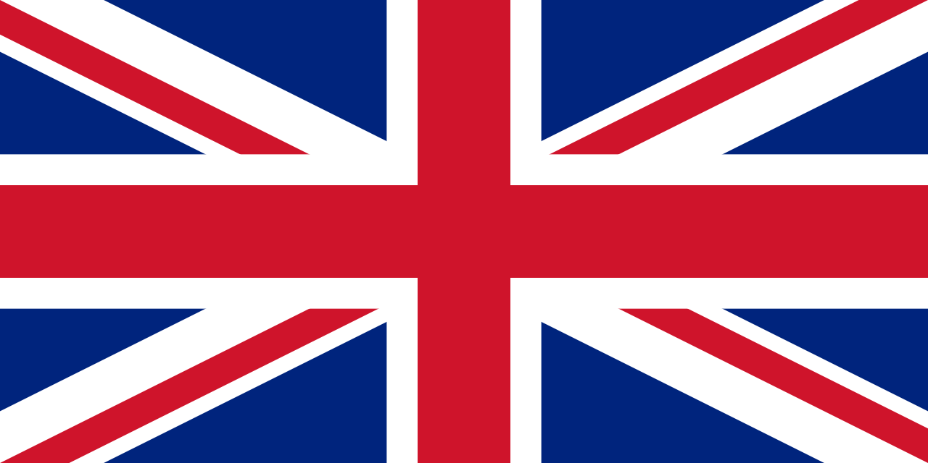

7.1.3: Students will compare and contrast diverse social and economic structures within the societies of Aboriginal, French and British peoples in pre-Confederation Canada by exploring and reflecting upon the following questions and issues:
7.1.3.3: What were the social and economic factors of European imperialism?
7.1.3.4: In what ways did European imperialism impact the social and economic structures
of Aboriginal societies?
7.1.3.8
7.1.3.9

VOCABULARY:

TERM | DEFINITION
Beothuk

Mercantilism
Northwest
Passage

Sovereignty

KEY CONCEPT: MERCANTILISM

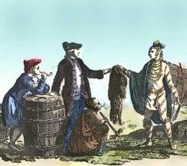
What is mercantilism?

Many imperial powers from Europe used the mercantile system to grow powerful.

What 4 products were considered the most valuable?

__________________ __________________ __________________ __________________

Why did the home country want these products?_____________________________

Did they worry about how many resources they were using?______________

Perspectives of Mercantilism

State who might have said the following quotes.
(use page 53 in text book)
“I love making money by selling goods at a very high price” | “I love power and money. Let the colonies make me rich”
“I think my life is hard in the new colony, but it was very bad back home too” | “We have always wanted to share our resources, but these new comers want our homes too”

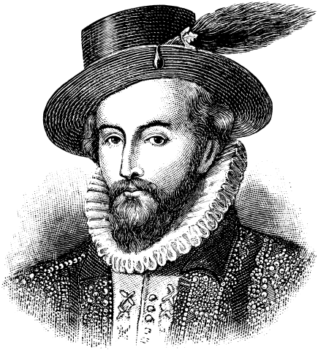
THE BRITISH CROSS THE ATLANTIC:

Who was Walter Raleigh?____________________________________
_________________________________________________________

Where did he come from? ___________________________________

How many times did he try to settle? __________________________

What four main reasons did Britain have for wanting to build colonies in America? (page 55 of text)

Britain wanted to make __________________ like other countries.
Britain did not want Spain and France to become more _____________.
Britain was running out of good ___________________ and the new colonies could hold more people.
Many _______________ groups were not able to practice their religion freely in Britain.

King James I of England knew it would cost a great deal of money to set up colonies. So that he wouldn’t lose money, what did he do?
___________________________________________________________________

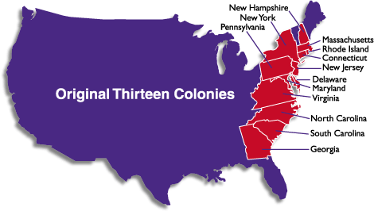
13 COLONIES:
Each had its own unique social structure, religious group and government.

What goods did the 13 colonies have to sell to England?

What goods did England sell to the colonies?

 | New France | Thirteen Colonies
Different Goals

Climate

Employment

Religion

Trade

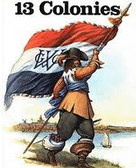

Where did most people want to live?

___________________________________________________

The British Colonies in Atlantic Canada
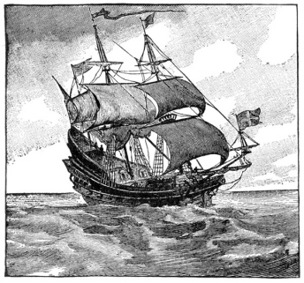
What year did John Cabot arrive in Newfoundland? _____________________

How did he describe the fishing situation? _____________________________

Why didn’t the British want to colonize the “New Found Land”? ____________
________________________________________________________________

What did King George II eventually do? __________________________________________________

By 1729, what happened to Newfoundland? ______________________________________________
__________________________________________________________________________________

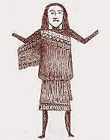
Extinction of a Nation

Read the story of the Beothuk people. Write a paragraph that summarizes what you feel happened in this situation.
_______________________________________________________________________
_______________________________________________________________________
_______________________________________________________________________
_______________________________________________________________________

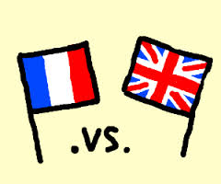
Britain and France Against Each Other
Over in Europe, Britain and France were at war with each other. In 1713, they signed the ____________________________ to create peace in Europe. Each country was given land and the habitants were allowed to live there in peace. BUT this did not last long.

- The French kept control of the Fortress of Louisbourg on Ile Royal (Cape Breton)
- The British were given the colony of Acadia (which had belong to the French). The British renamed the colony Nova Scotia. For the time being they let the Acadians stay and live their life normally.

Britain decided to show its sovereignty over Nova Scotia. What does this mean? ________________
__________________________________________________________________________________

Where did Britain set up a base in Nova Scotia? _______________ (which means “the biggest colony harbor”). It had a town, fort and houses. What did the British decide to call it? ________________

The Mi’kmaq became more concerned about the British newcomers because they were settling on their land. In response, what did the British Governor do?
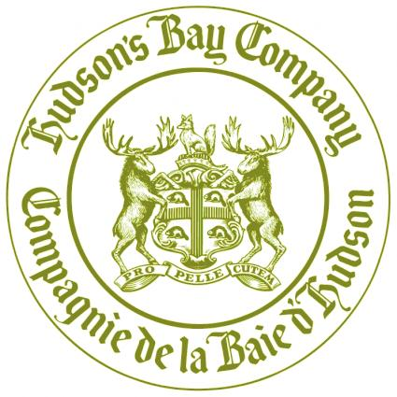
The Company by the Bay

Who were the two explorers who founded the Hudson Bay?
__________________________ & _______________________________

What did King Charles II of England grant the Hudson Bay Company?
_______________________________.

What land did it cover? ___________________________.

Why were Britain and France at war for so many years over Rupert’s Land? ___________________________________________________________________
INTERESTING FACT: The English (Hudson’s Bay Company) called their trading posts FACTORIES. The trader in charge of a post was called the FACTOR.

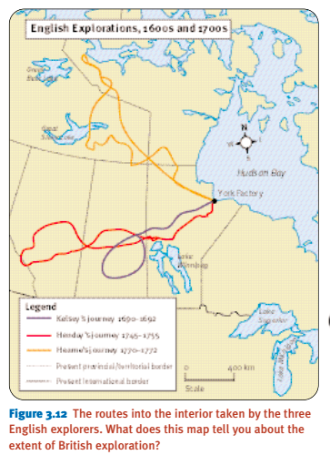
The British Continue To Explore
Who did Henry Kelsey work for? __________________________________________

What was his main goal as he left the trading post?
__________________________________________
__________________________________________

How was he going to convince the Aboriginal people to go along with him? _____________________________________________
_____________________________________________

Where did Kelsey end up travelling? _______________
_____________________________________________

West into Alberta

Who did Anthony Henday work for? _______________

What was his goal? ___________________________

Where did Henday travel to on foot in 1745? __________________ Why did the Siksika society refuse to deliver the furs? _______________________________________________________
_____________________________________________________________________________
BIOGRAPHY: Mantonabbee: Read the biography on page 69. Why do you think Matonabbee was so important to the exploration of Canada? ____________________________________________
________________________________________________________________________________

The Search for the Northwest Passage

What were Europeans trying to find? ___________________________________________________

Who was Sir John Franklin? ___________________________________________
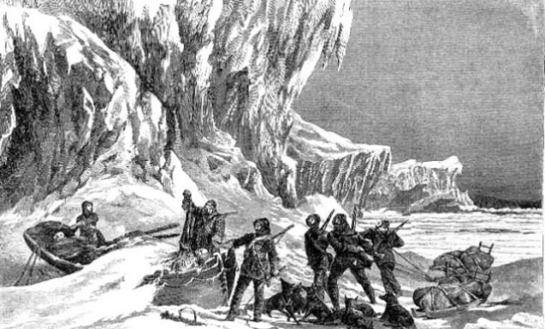
What happened to Franklin and his two ships?
__________________________________________
__________________________________________

Who was the Norwegian sailor who sailed into the waters north of Baffin Island?
_________________________________________

Who were the other explorers who tried to find the Northwest Passage beginning at the Atlantic Coast? ________________________________________________________________________

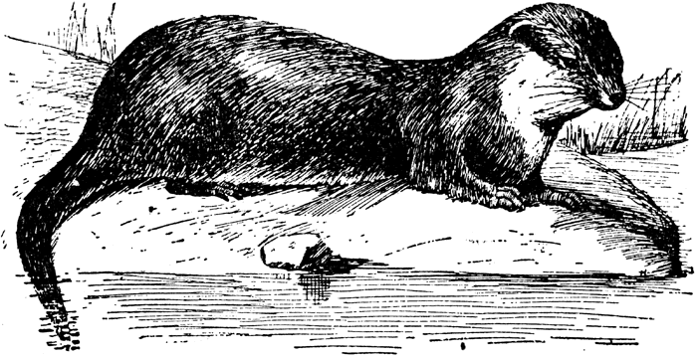
What animal did they hunt? _________________________

What is another name they called it? ________________________

BIG IDEA: The British played a key role in the exploration and colonization of
North America:
- Built colonies – First English speaking communities
- Benefitted from the rich natural resources
- Travelled up and down the coast
- Various and multiple contact with many First Nations

