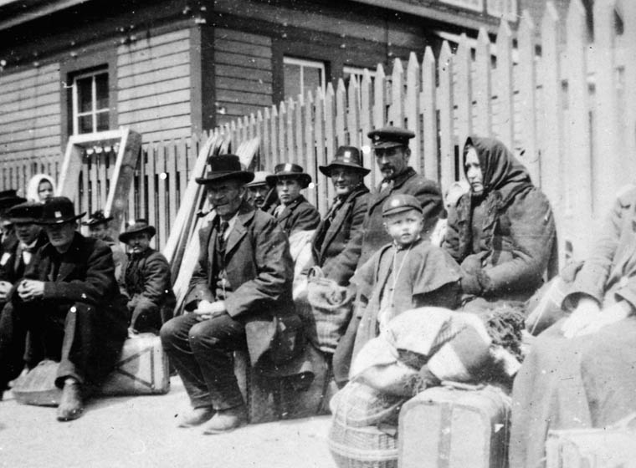
Chapter 12: Changing Societies in the
West

Chapter Inquiry – Was the impact of Canada’s immigration policy on each of the peoples in Western Canada positive or negative?
Vocabulary – Use the glossary or text to define the following words.
Policy
Numbered Treaties
Assimilation
Residential Schools
Official Language

Key Concept – People and Policies – There are meanings for the word . Governments have general policies about how a country should be . A policy lays out a plan of to achieve a specific . Policies can affect and communities in negative and ways. This chapter shows what effects the government had on the people of Canada in the late and early 1900s.
Government Policies and the Peoples of the West – Remember that the Policy was meant to help Canada to grow as a nation. It had main policies included in it, what were they?
- policy – to encourage to in the West.
- policy – to a .
- policy – to help the to .

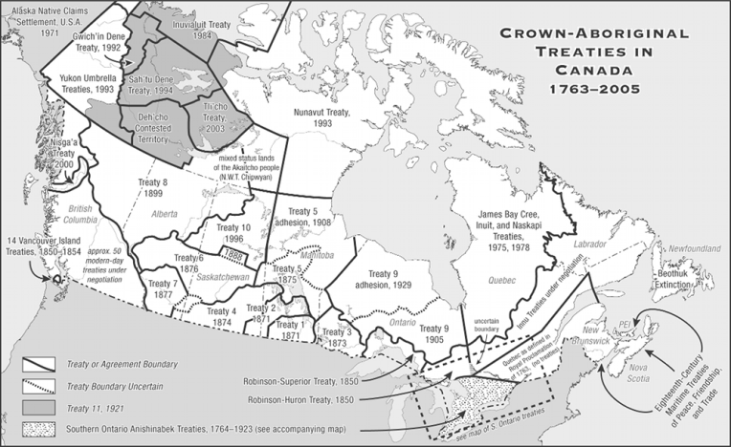
Treaties in the West –
The First Nations and were the first to feel the effects of new settlement in the West. Buffalo had become , miners and were moving into First Nations . Land that was good for hunting was being turned into . Europeans brought diseases such as and that was dangerous for the Aboriginal people.
Different Reasons – Between and 1921 the First Nations between the Great and Mountains made treaties with the Canadian Government. These treaties were known as the Treaties.
The main purpose of the treaties for the Canadian Government was to get of the land and resources. If the First Nations did not allow the homesteaders onto their , the immigration plans would . Prime Minister John A. Macdonald didn’t want to have between the Government and First Nations people like what had happened in the .
The main reason that the First Nation’s people agreed to treaties was to: . The government knew their _______________ plans would fail without this land. First Nations main reason for agreeing to the treaties was to ________________ their ____________ to their land and natural ________________.
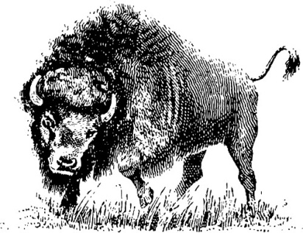
They needed the and the Government was promising because they were with starvation (from the disappearing ) and (from the Europeans). They hoped that their and _______________ would survive.

The Treaties – Each treaty was slightly , but the main thing was that the Government to provide First Nations with payments and certain goods (such as and equipment) and services (such as and ). In exchange, the First Nations would _________ the homesteaders onto their . Certain areas of land, called , were set aside, only First Nations peoples were allowed to there.
The Canadian government and First Nations often ended up with different as to what was agreed upon in these treaties.
Assimilation – The Canadian government had a policy of . They thought that if the First Nations would lose their and they would become like the . They did this by taking the First Nations _______________ from their and putting them in residential where they were not allowed to their own or practice their own .

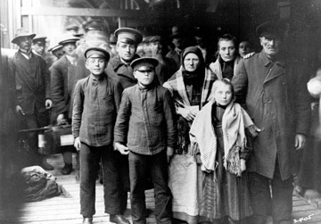
PEOPLES FROM EASTERN EUROPE –
People from Eastern Europe benefited from Canada’s immigration policies. These were the ___________ number of newcomers to the and included , , , and .

Push & Pull Factors - Life in Eastern Europe around 1900 could be very . Many families lived in and people could be sent to or ______ for practising a different . Doukhobors, Mennonites and all suffered from these kinds of . These people were promised land and religious if they came to Canada.
Contributing to the Economy – Many Eastern Europeans preferred large ___________ farms and these became the base of Canada’s _______________ industry. They already had the _____________ and ____________ needed to farm in the West. Other Eastern Europeans worked in the and camps or helped to build the . Others opened and supported the economy of Eastern Canada.

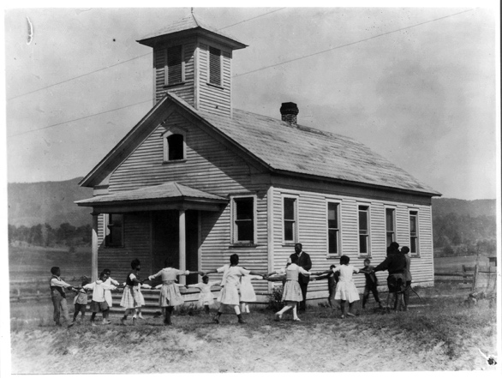
Education and Health – Schools were not the first thing on their minds, but they would build them for their communities as soon as they could. Many of these immigrants could not a doctor if they were and there weren’t any medical so they formed societies that could provide a simple form of health if it was required.

Cultural Activities – As soon as possible, people would a church or in their community, where they could practice their . They formed clubs, societies, dance groups, and other organizations to follow their customs and enjoy together. Culture is a learned _________ of __________and it is through common _________ that these communities stayed .

Citizenship and Identity – The people of the different ethnic origins each other and took of their new freedoms to get involved in ___________. Today there are more than million Canadians are of Eastern European ___________

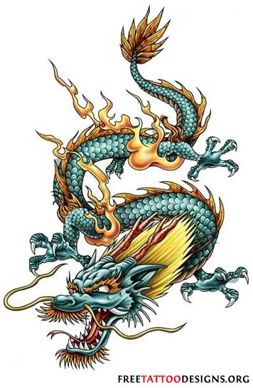
Chinese Immigration to the West – People from were some of the earliest immigrants to ________________Canada. The first Chinese came in with the rush in and thousands joined them later on to work on building the .
Choosing to Stay - After the railway was finished in many Chinese found jobs as cooks, and . Many went to work in __________ canneries or settled on the ___________. Many opened businesses such as and or sold vegetables from their . Alberta had the number of Chinese immigrants in the west and many of them worked in the coal , on farms or as ________ on cattle ranches.
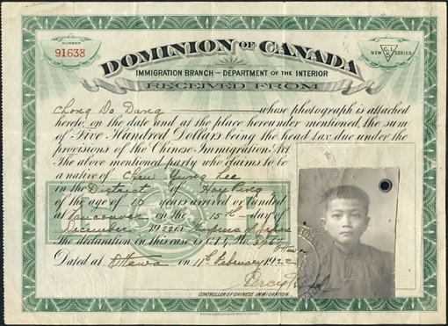
A Change in Policies – After the CPR was the Government started to pass to keep Asian immigrants of Canada. Many non-Asians believed they would not ________ into Canadian ____________ and feared the different ____________ of Asian newcomers. Many were also afraid that the Asian immigrants, who were paid lower __________ would take available from other Canadians. One law to keep out the Asians was the Chinese tax which was a that every person from China had to to enter Canada. It started in 1885 & cost $ per person. Later it would be increased in to $ . In 1923 Chinese immigrants were totally from entering the country. Attitudes toward Chinese heritage finally began to change in the late ____________.
Chinatowns - The Chinese people to certain neighbourhoods which came to be called .

From Majority to Minority: Francophones in the West –
Immigration resulted in big changes for communities in the West.
A Storm Brewing - Francophone culture and language was in the West until the late . But with the many non-Francophone immigrants , French became just of many different languages that were on the prairies. New immigrants were expected to learn , not French, and over time they and their became Anglophones. Anglophones became a bigger __________.

Using French in Government – When Canada was created in _________ the ________________ Act guaranteed that either ___________ or ______________ could be used in the Assembly. French and English were __________ in government and _________. In 1870 the Manitoba Act made and English languages in the Manitoba Government. In 1890 the government of Manitoba made the only language in the province and this lasted for years until it was changed back to the original laws in . In the provinces of Alberta and Saskatchewan, the _____________ Resolution in 1892 made the only official language. For almost _________ years Alberta & Saskatchewan gave no __________ status to the French language.
Franco-Alberta Citizens in Action - In 1988, the Alberta Government realized that it needed to change the Alberta Act. How did Alberta include the rights of both English and French speaking students?

Building An Economy – By the ______ the government and people were happy with the way the ___________ was going. All across the __________ small communities along the ______________ were growing into busy towns and cities.
Ranching in Alberta (page 283) Read the case study that tells of the history of ranching in Southern Alberta. Find the answers to these questions.
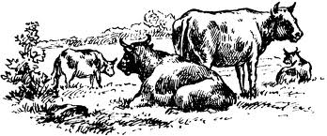
Why did the cattle do so well on the grasslands?

As ranches developed, how did they contribute to the Alberta economy?

An Unfair Policy? – Many Western farmers believed that the economic policies of the Government benefited the more than the of Canada. The ___________ the government had put on the foreign _________ meant farmers had to pay high prices for farm ______________. Some felt it cost ________ to ship the grain than what they were getting __________ for it. Because of this the western farmers formed the Grain Growers and the ____________ Farmers of ____________. They formed their own marketing association to help their grain.

