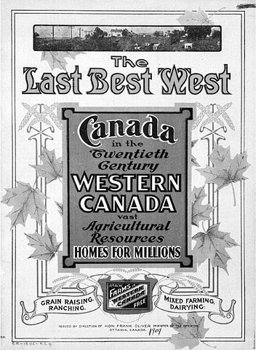
Chapter 9 Project - Promotional Poster
It is the late 1800’s and you are an advertising agent for the Government of Canada. You job is to create a promotional poster that sells the Canadian West and how the country is prepared for a massive influx of immigrants to move there.
You must include information on:
- The many different natural resources
- The abundance of land for farms
- North West Mounted Police for protection
- The Canadian Pacific Railway for transportation
- National Policy:
- Transportation Policy- transcontinental railway
- Immigration Policy- get farmers to move West
- Economic Policy- protective tariffs
You can include testimonials from important people such as Jerry Potts, Sir John A. MacDonald, Father Albert Lacombe or Dolly Watts.
Be sure to include information and graphics that will convince people to come to the west and settle the land. A title is essential to convey your message for example: Come to Canada, Time To Travel, Settle Where The Land Is Free, New Beginnings. Remember it is the 1800’s and there are no computers so yours poster should be done without the use of this technology as well. Make sure that you use eye catching colours, graphics and words that are important to sell your message.
You will be marked using the following rubric:
Criteria | 10 - Excellent | 8 - Proficient | 6 - Basic | 4 - Limited
Creative Thinking | Produces an elaborate and engaging message to convince settlers to move to the west. | Produces a detailed and interesting message the might convince settlers to move west. | Produces a general and matter of fact message that is not overly enticing. | Produces a vague or confusing message that does not give settlers motivation to move.
Visual Literacy | Presents in a way that is persuasive and engaging and has a purpose that is consistently clear | Presents in a way that is mostly credible and interesting and has a purpose that is mostly clear | Presents in a way that is partly logical and has a purpose that is somewhat evident | Presents in a way that is unhelpful and confusing and does not show purpose
Written Literacy | Includes all content from the project description. | Includes most of the content form the project description | Includes some of the content from the project description but lacking in detail. | Missing important facts from the project description.
Total /30

