Chapter 6: Becoming Canada
Name:___________________
Chapter Inquiry: How did the War of 1812 and its political consequences affect the developing Canadian identity?

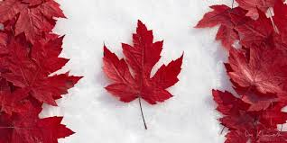

7.1.6: Students will assess, critically, how political, economic and military events contributed to the foundations of Canada by exploring and reflecting upon the following questions and issues:
- 7.1.6.4: What was the role of Chief Tecumseh in the War of 1812?
- 7.1.6.5: How did the War of 1812 contribute to British identity in Canada?
- 7.1.6.6: How did the War of 1812 contribute to defining Canada’s political influence?
- 7.1.6.7: How was the Great Migration of 1815-1850 in Upper Canada and Lower Canada an attempt to confirm British identity in the Province of Canada?

VOCABULARY
Term | Definition
Personal Identity
Superficial Characteristics
United Empire Loyalists
Traitors
Refugees
Discrimination
Immigrants
Quarantine Station
Legislative Assembly
Chateau Clique
Family Compact
Patriotes
Ninety-Two Resolutions
Reformers
7th Report on Grievances
Responsible Government
Liberators
Deadlock

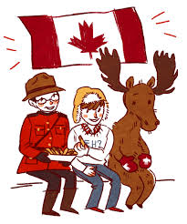
A Complex Identity
When people get to know you they learn things about you like your sense of _______ , and . They get to know your personal identity and this lets us each other better. Like people, countries have characteristics. When people around the world picture Canada, they think of , the Mounties, the _ , and . They might recall that Canada is the ______ largest country in the world. Can you think of three other things? _________________________ _____________________________________________________________
Do these characteristics really say much about Canada? Do other people in the world know anything about Canada’s First Nations? Or that Canada is officially and that poppies bloom in the ? Canada’s identity is very complex and depending on who and where you are, Canada is many to many different people.

Rebellion in the Thirteen Colonies
Britain’s Thirteen Colonies south of the St. Lawrence River were . By 1765 they were growing under ________ rule.
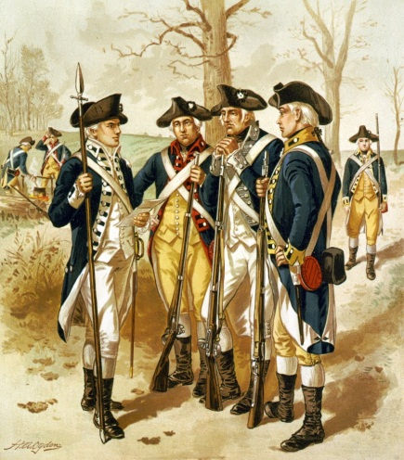
Give 4 reasons that the Thirteen Colonies were becoming restless with living under British control.

In April of 1775 the first shots of the War of were fired. The American rebels hoped that the Canadiens would their revolt. So first they captured and then they moved on to _________________ City to do the same.

Invaders or Liberators?
Provide three reasons why the invasion of Quebec City failed?
- The Seigneurs
- Most Americans
- The Habitants
The Americans faced fierce on the last day of they attacked Quebec City in the middle of a blinding . The rebels got in the maze of narrow streets of the city and were easy for the British and defenders. The Americans called their . In 1783 Britain finally the of America after many years of fighting for their .
Citizens Loyal to the King – What reasons did the United Empire Loyalists have for opposing the war in the Thirteen Colonies?

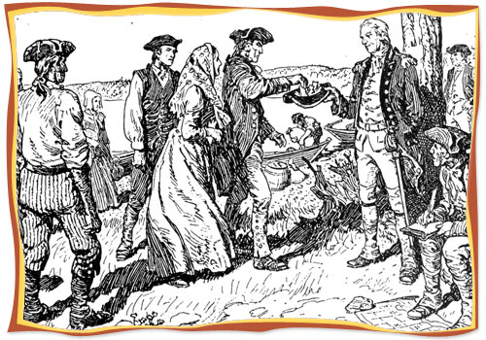
Why did most of the Loyalists seek the shelter and safety of Canada?

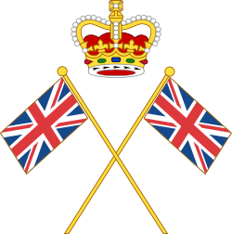
Loyalists Head to Nova Scotia – During and after the war almost Loyalists migrated to the British Colonies. Many travelled to ______________________.
Britain made promises to the Loyalists, what did they say that they would do? . Some got the land but many didn’t. Life was very for all especially for the Loyalists. Their land wasn’t very good for ___________________. When they farmed a plot of land they had to give _______________the money they earned from their crops to the ____________________ . They faced __________________ and discrimination but many and overcame the anyways.
New Colonies – Many of the Loyalists were in Nova Scotia and they wanted their own . In 1784 Britain agreed to Nova Scotia into ___________parts. The western part would become . Cape Breton Island became a separate colony and Ile Saint-Jean was renamed .
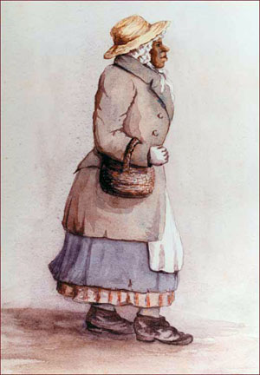
Rose Fortune ( – 1864) Who was Rose Fortune? Where did she come from? Why did she go to Nova Scotia? How old was she? What did she do when she got there?
______________________________________________________
The Loyalists Come to Quebec – Loyalists also went to and waited for Britain to help them. Most did not want to stay there because of the language, Roman traditions and all of the good had already been . The Governor of Quebec Sir gave them land along the upper . River and north shore of Lake . This land had belonged to the First Nations but was traded for some and other trade goods.
Land, Identity, and the First Nations – How did the loss of their traditional lands affect the first nations identity? The Mohawk leader was called (his English name was Joseph ) and demanded that the British give his people . Eventually he was successful and they gave the land where the Six Nations reserve sits today on the Grand River, north of Lake .
Building a Bilingual Country – Most of the Loyalists who came to Quebec spoke ______ because they came from colonies that had British and . In Quebec the French formed the so the Loyalists wanted a colony where they could keep their own . In 1791 the divided Quebec in two. The land west of the Ottawa River became (now southern Ontario)
The land of the Ottawa River Became Canada (now Quebec)
What do the terms Upper and Lower Canada refer to? ____________________________________________________________
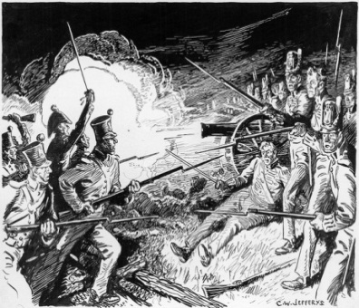
Conflict Renewed: The War of 1812
War broke out between Britain and the United States in 1812. Why couldn’t Britain and the United States get along?

- ______

The war began in and the British wondered if they could count on the of British ________________ America.

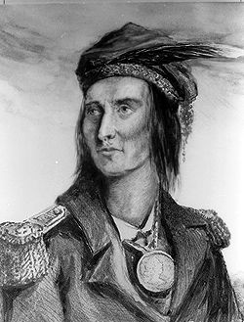
Read the Biography on Tecumseh. Provide the following information:
When was he born? When did he die?
What was he?
What did he do when the war broke out in 1812?
What did he accomplish?
Tecumseh
What happened to him?

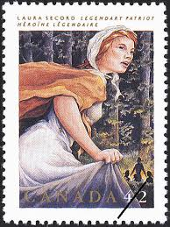
Who was Laura Secord and what did she do?

The War Unfolds – In a fleet of American ships in Lake Ontario fired on the town of York which is now called . The American soldiers the and houses and they down the building. What did Britain do to retaliate in August of 1814? ___________________
The Impact of the War – The War of 1812 ended in a . The treaty of ended the war in December of . What did it require?
The Americans thought that they had the war over Britain but the people of and Lower thought that they did because they managed to stop an American attack for the time. The First Nations could _________ claim victory because about of them in the war. The Americans refused to create a First Nations as had been proposed by the . .
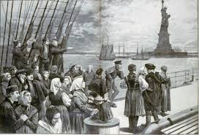
The Great Migration
After the war Britain wanted to open up the back to farming. Between and 1850 about ______________ immigrants came to the ports of , Saint John, and City. These immigrants were from , , Wales and . This became known as the .
Why did so many people want to leave Britain to live in the colonies?

Coming to the Colonies – Immigrants travelled from Britain to Canada by __________. It was a long journey that lasted for many . Most of the immigrants were very . The people were ________ into the dark and filthy holds _________ deck, where disease ran ______________. These boats were called ___________________ and many people died on these voyages. Most immigrants travelled by from Quebec City and to Upper Canada.
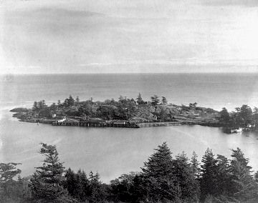
The Terrible Year – At first about people arrived each year from Britain. Two-thirds were from . By 1847 immigration from Ireland grew to per year. There was a in Ireland because the crop had failed, the Irish had nothing to _______. Then a ____________ epidemic broke out on board the ships and thousands on board the ships.
What was Grosse Ile and what was its purpose?
Pioneer Life – What challenges did the newcomers face when they finally reached their plot of land? __________________
A Very British Colony – How did the arrival of so many people change the identity of the British Colonies?
- Newcomers -
- New industries -
- Towns -
- People worked -
- They brought a British flavour -
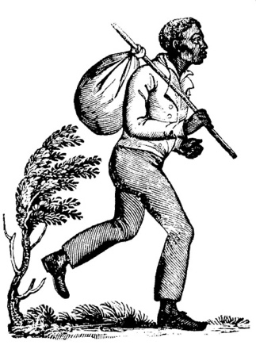
The Underground Railroad – In 1833 Britain banned in
all of its including Canada and it soon became known as a ____ haven for American slaves. Many slaves went north via the ____ . This was a network of people who would fugitives during the day and then moved them at_________ to the next station. In this time more than former slaves reached the British colonies. In _______ the United States ended . While about half of the former slaves ____ to the United States, many of them stayed and created their own strong communities and unique .

Divided Society
The population of British North America grew and so did the tensions. The constitutional Act of ________ gave each of the British colonies a new form of government consisting of a ____________and an assembly.
Government in the Colonies - Although the Legislative assembly was elected who held the real power?
Council members were (English speaking) friends and relatives of the . In Lower Canada they were called the and in Upper Canada they were called the . They passed laws that their own .
Explain why many colonist thought that this was unfair and what did they call themselves? ____________________________________________________________________________________
By 1830 people in Upper and Lower Canada were . Each group had reasons for feeling this way.
Rebellion in Lower Canada
What was the group that were unhappy in Lower Canada called?
Who was their leader?
What did they want?
What did the British Government do? .
What happened after the British forces destroyed the rebel force at Saint-Eustache? .
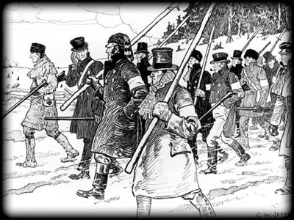
Rebellion in Upper Canada
Rebellion was brewing in Upper Canada by .
What did the rebellion group call itself in Upper Canada? .
What was the name of their leader?
What did they do?_____________________________________________________________ .
What happened when they first clashed with the government supporters? .
What happened after a few days of violent clashes? .
What happened to Mackenzie? .
What was the lasting impact of the rebellions __________________.

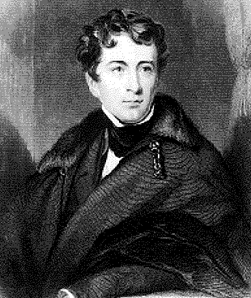
The Road to Responsible Government

Lord Durham’s Report – The British government decided to find out more about the of the ___________________________.
Who did they send to Canada to find out the answers to the causes?

What two main recommendations for change did he make?

The Union of the Canadas – What issue did Durham blame for the troubles in Lower Canada?
Durham wanted to get rid of the Language in Quebec. He thought he could do this by the two colonies. Britain to the plan and in 1841 the of created a colony with two .
Lower Canada became
Upper Canada became __________ _____________
What was the only official language of the government? _____________________
How did the Canadiens feel about the arrangement? __________________________

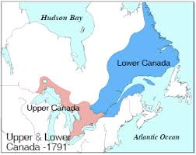
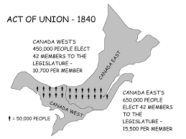

Achieving Responsible Government:
In responsible government the representatives in the Assembly express the of the and the governor would then follow the wishes of the . This way the Governor’s is kept under control.

In the Reformers won an victory. The People wanted ___________________ so Lord chose _________ Reformers to lead a new .
- Baldwin
- - Hippolyte – La Fontaine.
Elgin agreed to their advice. At last responsible was a .

