Explore The Explorers – Research Project

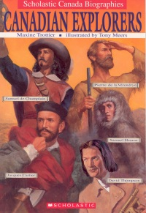
You will research and create a poster displaying an explorer and his contribution to the development of Canada.

Some suggestions for explorers to research are:

James Cook Samuel de Champlain
LaVerendrye Sir John Franklin
Henry Hudson Sir Alexander Mackenzie
Anthony Henday Radisson and Groseiliers
Martin Frobisher George Vancouver
David Thompson Jacques Cartier
John Palliser Samuel Hearn

Your poster should be divided into five sections.

Section 1: About the Explorer or The Early Years

- The name of explorer that you have chosen
- Give your poster a title
Cartier - Navigator & Explorer
Radisson & Groseileirs - Not In It For The
Money
- Where and when he was born as well as, when, where, and how he died
- Information about his family, his childhood, schooling, and early interests
- Information about any other training
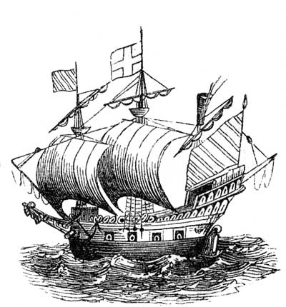
- Information about people that may have influenced him in the early years
- Any other personal information about your explorer

Section 2: The Country That Supported The Expedition

- Name of the country that supplied the ships, etc.
- Name of the rulers of that country at the time
- Crew and ship information. The number of expeditions
- Why they supported the expedition (what was the purpose and why did they pay for the trip)?
- Any other facts about this country that will add information about the expedition(s)

Section 3: About the Expedition or the Journey

- Tell what they found: people, land, resources
- Tell where the expedition traveled and report on any problems they encountered
- Describe the most important expedition in detail
- how did they travel (e.g. ship, canoe, dog sled, foot, horseback)
- hardships that he encountered
- people he met along the way (if anyone)
- was the mission considered a success at the time?
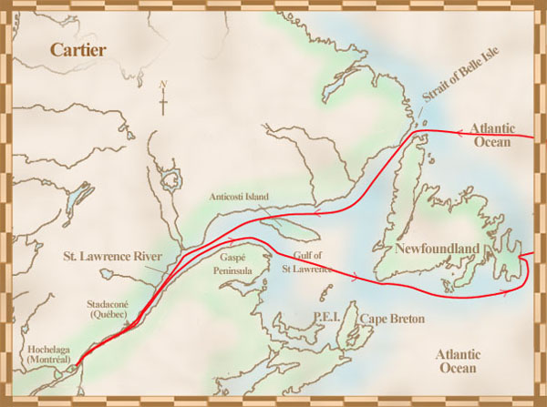
Section 4: Mapping the Expedition
- Identify the oceans and continents of the world on a map.
- Include the country your explorer sailed for.
- Retrace your explorer’s journey(s).
- Use color markers and highlight the voyages in different colors.
- Use a color key and date the voyages.

Section 5: A Portrait of the Explorer
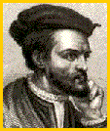
- Draw and color a portrait of your explorer or find a picture on internet that you can use
- Create a border for the portrait
- Label the portrait with a name and the date he was alive
- Conclude with how your explorer contributed to the development of Canada.

Section 6: Resource
- On the back of the poster you MUST include a list of the references you used to find your information.
    - Author, year, Title (or link)
You can use any or all of the following (keep a list of the resources you use)
- Your text books, WWW search through a search engine
- library books, videos, DVDs, Atlas, and other reference material

Explore The Explorers – Research Project

Name: __________________________________

You will be marked using the following rubric:

 | Excellent | Proficient | Basic | Limited
Conclusions about the explorer support their contributions to Canada’s development | Expresses insightful & reflective contributions | Expresses thoughtful contributions | Expresses basic ideas about the explorer | Expresses vague ideas about the explorer
Written and visual literacy: presents in a way that is engaging and purposeful | Presents in a way that is persuasive and engaging and has a purpose that is consistently clear | Presents in a way that is mostly credible & interesting and has a clear purpose | Presents in a way that is partly logical & has a purpose that is sort of evident | Presents in a way that is confusing and/or does not show purpose
Research Process: accesses and organizes relevant and varied information. Includes resources. | Accesses a wide variety of relevant information & organizes it clearly and effectively. Resources are properly sited. | Accesses a variety of mostly relevant information & organizes most of it logically. Resources included but not properly sited. | Accesses some basic information, although some may be irrelevant. Resources not included. | Accesses little relevant information; does not organize the information
Total /50

