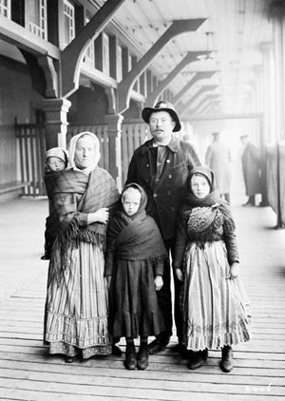
Chapter 11: Encouraging Immigration
Name:

Chapter Inquiry – How did the massive immigration to Canada near the turn of the twentieth century affect the complex identity of our country?
Vocabulary – Use the glossary or text to define the following words.
False Advertising
Immigrant
Emigrant
Push Factor
Pull Factor
Pluralistic Society
Persecuted
Pacifists
Internal Migrants
Discrimination
Communal Lifestyle
Settlement Patterns

Key Concept – Immigration and Identity
Canada is a different country today from what it was years ago. One of the factors that change a country’s identity is . Many people come from other to live in Canada and these newcomers bring their own & . These newcomers to what it means to be Canadian.
Coming to Western Canada – At first Canada did attract many immigrants. Most people that came to North went to the . In the 1890s things and newcomers flooded the .
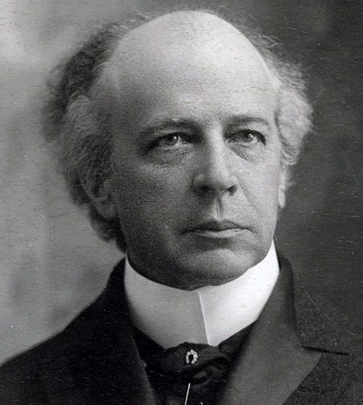
The Need for Immigrants –
In 1881 there were people living in Canada, this included the 108,547 people. Almost % of Canadians were of , and descent and most lived in the part of Canada. .
The Western part of Canada had First , Metis, Canadien fur and some Canadians who had moved from eastern Canada, but there many people living in the west.
The Laurier Factor – Sir was Canada’s first Canadian Prime Minister. He thought that Canada could become a great nation and said “The twentieth century belongs to Canada”. But it would not happen without to start in the West. A strong farm economy in the West would help the ________ country.
Prime Minister Wilfred Laurier
- Using Figure 11.2 on page 246 of your text book, what year saw the greatest number of Immigrants come to Canada?

- What year saw the fewest number of Immigrants come to Canada?

What four things did Laurier do to succeed in getting people to move to Canada?

Partners in the Effort – What things did the government and private companies do to attract people to Canada?

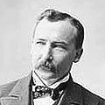
Canada Calling –
The person that was in charge of to Canada was Clifford . He started a campaign to people to Canada.
What three things did government do in this campaign?

What places did the Government target, and why did they target them?

___________________________________________________________________

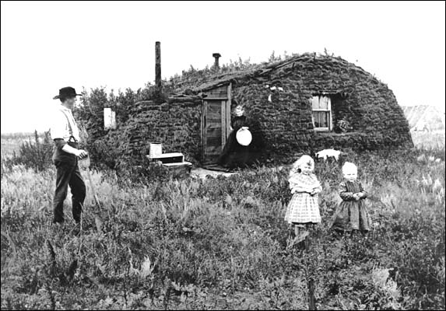
Betrayal of the Promise of Confederation - Sifton & the wanted the new citizens to speak or be willing to learn it. They did not try to convince the from Quebec to move . They thought that Canada should be nation with language. The felt betrayed because Confederation had made Canada . Within decades the Francophones were far in the West.
The Trap – Life in the West was much than the had led them to believe. There were very few so newcomers made houses out of . Which are slabs of soil, and grass roots cut from the prairie and they didn’t make the best . Few had enough to pay for the trip back home so they were “trapped” in the conditions.
Push and Pull Factors –
The people who came here had reasons for leaving their and choosing Canada.
Reasons for Emigrating – For many, the in their homelands made them want to . The factors that push people to leave their homelands are called push factors. What were the main push factors for the newcomers to the West?

Reasons for Immigrating to Canada – Why did many choose to move to Canada? Factors that people to choose a certain country are called pull factors. What were the main pull factors that brought people to Canada?

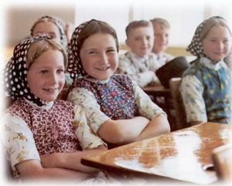
Churches and Immigration –
Churches and groups took special interest in to the Canadian West. In some cases, church members were for their religious .
- Doukhobors & Hutterites – Were people who were being treated badly in Europe for their religious beliefs. They were _______________
Read the case study on page 254 about the Hutterites that live near Lethbridge. Describe the three things that are common to a communal lifestyle.
- No private
- Everyone everything – farm equipment, books, toys, bank accounts
- Everyone lives together in a small

Describe who British Home Children were: ______________________________________
____________________________________________________________________________________________________________________________________________________

Francophones in the West – Francophones were the first - people in the West and had been living there since . What things did the Francophones do that left a mark of their early existence in the west?
- They named many , , , parks, communities with names.
- Early Francophone farms on the Red River are and , with homes near the and were based on the system of New France.
- Many hospitals and were named after French Catholic
- Many were started by Francophones such as mines, banks, and businesses.
Internal Migrants - People who moved from one to another within the same country are known as migrants. These Canadien migrants were people who were initially attracted to moving west for several reasons including:
- The system - Francophone schools and the courts. However, as time went by Canadiens began to see the government would rather make the West ____________________.
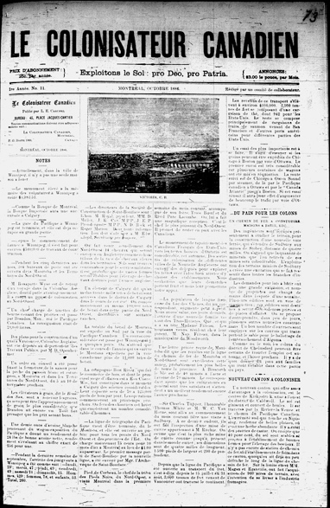
Boosting the Francophone Population:
- Catholic church - attracted French Catholic
- Francophone was distributed
- As a result of these efforts, by 1921 _____________ Francophones made up about 7% of the population on the Prairies.

Settling In –
By 1911 more than % of the people living in the Western provinces had been born outside of . What was special about all the work the hard work these people accomplished in the west? ____________________________________________ ________________________________________________________________________
List 12 different ethnic groups that settled in Canada between 1881 and 1911.

The Great Grain Growers - What became the most common and important crop being grown in Canada?
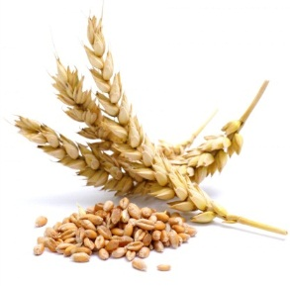
The Machinery – By the end of the 19th century, new ________________ was being produced that made farming _____________. Steam-powered ____________ replaced horses and ______________. The ______________ would carry the crop to distant ______________.
The Wheat – Canadian government _______________ produced a new type of ___________ that would ripen sooner in the season. It was called ________________ and ripened quickly. Westerners called it the “_______________________________________________________”. Wheat was also known as “prairie gold”
The Exports – Wheat became the most important _________ in Canada. It was shipped around the _______________ to ____________ many people. Other grains like barely and oats added to the harvest but in the West, _________________ was __________________.

