Chapter 10 Project: Expanding Confederation - Timeline
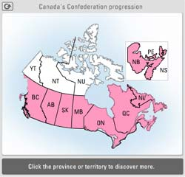
Your task is to make a timeline that shows the important dates of the Canadian Confederation. You must include the following:
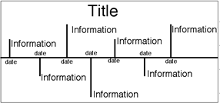
- 1867- Confederation of Quebec, Ontario, New Brunswick, and Nova Scotia
- 1870- Manitoba
- 1871- British Columbia
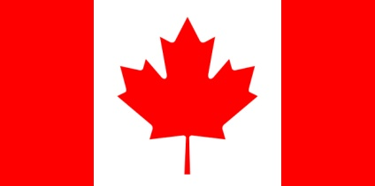
- 1873- Prince Edward Island
- 1898- Yukon becomes a territory
- 1905- Alberta, Saskatchewan
- 1949- Newfoundland & Labrador become a province
- 1965- Maple Leaf is adopted
- 1999- Nunavut becomes a territory
Using your textbook as a reference (page 166-167), you must include a minimum of at least 10 more important events and a maximum of 15 events. (This is a total of at least 19-24 events)
You must include a miniature hand drawn and coloured version of each provincial flag. Be creative (ex: create a boarder with the flags)
A title must be included, as well as your first and last name.
Your timeline should cover the years 1860- 2000 and be marked in ten year increments. Divide your line into three centimeter segments. Remember to clearly indicate the year of Confederation and the joining of each province and territory.
You will be marked using the following rubric:
Criteria | 10 - Excellent | 8 - Proficient | 6 - Basic | 4 - Limited
Historical Thinking- marks historical events | Broad and insightful timeline of Confederation | Detailed and credible timeline of Confederation | General and cursory timeline of Confederation | Vague, partial or incorrect timeline of Confederation
Visual Literacy- communicates clearly and purposefully | Timeline enhances communication and purpose | Timeline is clear and purposeful | Timeline is partly logical and somewhat evident purpose | Timeline is confusing or may contain errors
Total /50

