Chapter 8: A Little Graphic Novel: Louis Riel – Hero or Traitor

You will be the author and illustrator of a mini graphic novel that will tell the story of the life of Louis Riel. Your task is to argue a perspective that will attempt to convince the reader that Riel was either a hero or a traitor. Choose a title that will clearly express your opinion. Your book should include a small written component which will support the graphics and that will tell the story of the important Metis leader. It may include any of the following important events and more could be added if required. Be sure to explain the complete story including important dates, characters, events and locations in the telling of the story.

- Many English speaking people who lived in Ontario thought that Riel was a traitor and a murderer. They wanted him hanged.

- The French Canadiens considered him to be a hero. They thought of him as a defender of French language rights and the Catholic religion in the West.

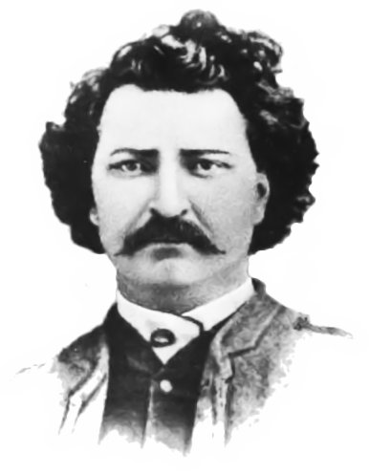
You have watched videos about Louis Riel as well as read information in chapter 8 of your textbook. State your opinion and then support it with facts to back it up. Some ideas for your novel may include:

- Early facts about Louis Riel (birthdate, birthplace)
- Grew up in Francophone Roman Catholic, Metis family
- Wanted to be a Catholic Priest when growing up
- At 25 years of age he was chosen president of Metis Provisional Government spoke out for Metis rights
- Involved in conflict between Francophone Metis and English speaking colonists
- Was blamed for leading the Metis - many wanted him punished
- Fled to the United States because his life was in danger
- Returned to Canada as the voice of the Metis “known as the heart of the Metis”
- After the uprising he surrendered and stood trial for treason
- He was found guilty and sentenced to be hanged
- Prime Minister Macdonald could have stepped in and stopped the execution but he wanted to get the English votes in Ontario in the Federal election
- “Riel shall hang though every dog in Quebec shall bark”
- Metis struggled to be recognized as a distinct group

Your book will only be 8 pages in length so you will have to choose the main events carefully to tell the story. Design an effective cover that includes the author/illustrator’s name. You will be marked with the following rubric.
Grading Rubric for Louis Riel Graphic Novel Project

Criteria | 10 - Excellent | 8 - Proficient | 6 - Basic | 2 - Limited | Mark
Creative thinking generates creative ideas about Louis Riel | Creates imaginative and insightful ideas about Louis Riel | Creates productive ideas about Louis Riel | Creates matter-of-fact ideas about Louis Riel | Creates vague of confusing ideas about Louis Riel
Historical thinking analyzes his life in a historical context and argues a perspective of hero or traitor | Provides broad, detailed and insightful analysis of the historical context including the important details of his life and events | Provides a credible and detailed analysis of the historical context – details are incomplete or limited | Provides a surface and cursory analysis of the historical context – lacking important and basic details | Provides a vague, partial or incorrect analysis or the historical context – with little or no historical details of life or events
Visual literacy presents in a way that is engaging and purposeful, | Presents in a way that is persuasive and engaging and has a purpose that is consistently clear | Presents in a way that is mostly credible and interesting and has a purpose that is mostly clear | Presents ins a way that is partly logical and has a purpose that is somewhat evident | Presents in a way that is unhelpful and confusing and/or does not show purpose
Effort and Originality the project shows effort and originality | Project is an excellent example of effort by the author and is entirely original in its design | A good effort was put into the creation and is mostly original in its design | Has limited effort put into the project and is lacking originality | No effort has been put into this assignment and it is not original in its design
Completeness and On Time the project has the essential elements , cover, artwork, written components and is handed in on time | All components are evident in the complete assignment and it is handed in on the assigned date | Most of the required components have been included and it is handed in on the assigned date | Some of the components have been omitted and it is a day late | Many of the components are missing and it is more than one day late
Total Score |  |  |  |  | /50

