CHAPTER 4
COMPETITION FOR TRADE
How did the various peoples in north America both work together in the fur trade and compete to control it?
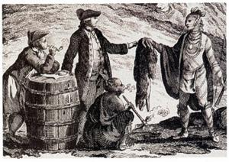

7.1.4: Students will assess, critically, the economic competition related to the control of the North American fur trade.
7.1.4.1: How did First Nations, French, British and Metis peoples interact with each other as participants in the fur trade?
7.1.4.2: How did the fur trade contribute to the foundations of the economy in North America?
7.1.4.3: How was Britain’s interest in the fur trade different from that of New France?
7.1.4.4: How was economic development in New France impacted by the changing policies of the French Royal Government.
7.1.4.5: What was the role of mercantilism before and after the 1763 Treaty of Paris?

VOCABULARY: Use the glossary or text to define the following words.
Barter
Canadiens
Cause
Economy
Effect
Ethnocentric
First Contact
Merchants
Metis
Nor’Westers
Pemmican
Perspective
Portage
Stockade
Voyageurs

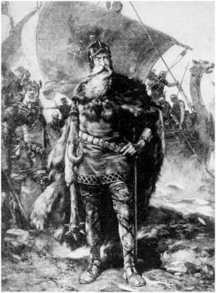
CULTURES IN CONTACT
The Vikings came to North America in the year . The next Europeans didn’t arrive for another years. The first contacts between the Europeans and the North American aboriginals happened along the . The Europeans and the First Nations peoples were very surprised to meet people who were from themselves.

- Depending on your perspective your observations can be very different from someone else. What does this mean?
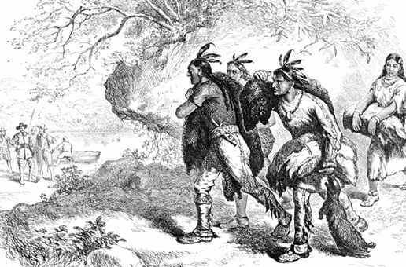
- How did the Europeans and the First Nations people learn to get along?
________________
Did this happen quickly? Why was it important that they get along with each other?
The Fur Trade: The Foundation of an Economy

Trading occurs when each side has something that the other would .
1. What items did the First Nations people like to get from the European ____________________
2. Why were these goods desirable to the ones that they already had? _____________________________
3. What kinds of goods did the Europeans want to get from the First Nations People?
_________________________________________________________________________

4. The Europeans used these things for _________________________________________
5. The First Nations People and the traders used the system when trading their goods. The First Nations people were already good at using this system when they traded to trade with their neighbors.
What did the Europeans usually use when they bought something back home?
_______________________________________________________________

6. Before trading they would show respect and trust by sharing the __________________ and offering a which is a string of shells to honour new friends and create harmony.
The Europeans were paid about times more for the pelts (furs) than they paid for the goods that they traded them for. This mark-up made them a healthy (big) _________________.

Three Key Players – There were three major groups involved in the fur trade. List them in the spaces below and explain the role that each played in the process.
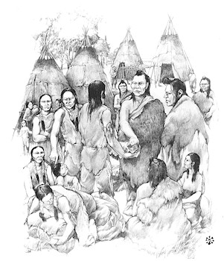
1. :
2. : ____________________
3. : ________________________________
_____________________________________________

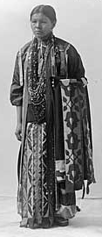
Relying on First Nations – The Europeans didn’t know how to live in the harsh North American wilderness, First Nations people helped Europeans in the following ways:

Although the First Nations Women did not hunt for furs, they still played an important role in the fur trade. In the space below list the ways that they played a role.

The French Fur Trade – How did the French government influence the fur trade and the economy of New France?

- Coureurs de bois spent their wages in - shop owners bought food from , farmers used that money to buy from other__________________.

- In the early days of New France the fur trade was the of the economy. Who controlled the fur trade in New France? __________________________________

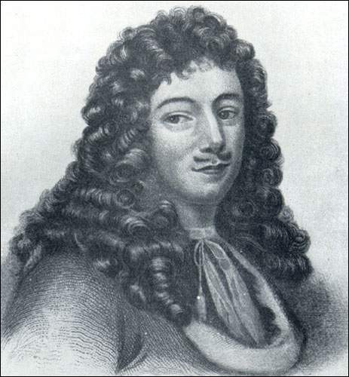
- Who was Jean-Baptiste Colbert and what was his role in New France?

- Who was Jean Talon and what was his role in New France? __________
Jean Talon
- Who was Governor Frontenac and what was his role in New France? ___________________________________________________________________

- In the Great Peace of Montreal, nations joined together to fight the
_____________________. After years of the First Nations and began to negotiate . They signed a peace treaty and finally the trappers and the could travel safely.

- When the local beaver supply began to decline the French their trapping farther and . This resulted in them exploring the entire continent. This Peace lasted until the .

Transportation: Crucial to Any Economy

- What form of transportation did the traders rely on? They used water routes because they were and .

- France controlled the fur trade along the and .

- The Mountains blocked the fur traders of the 13 colonies from expanding into the .

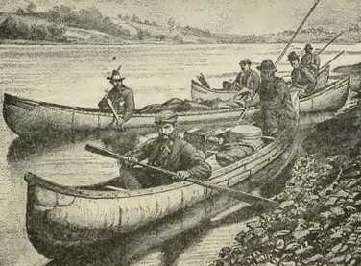
The Canoe – A Canadian Institution – The canoe played a very important role in the fur trade of early Canada.

- Without the canoe, travelling into the interior of North America would have been .

- Why were the birch bark canoes ideal for travelling?(3 Marks)

- What is the origin of the word Canoe?

- What do you think the First Nations People meant when they were talking about a great “Western Sea”?
Provide a brief biography of Pierre Gaultier de Varennes, Sieur de La Verendreye.
_____
The English Fur Trade
The English didn’t really want to build a , instead they just wanted to make in the fur trade.
The advantages of building forts along the shores of Hudson’s Bay were:
1.
2.
3.
Isabel Gunn was born in and died in .
Where did she live before she came to Canada?
What year did she come to Canada to be with her husband who worked with the Hudson’s Bay Co.?
Women were not allowed to do this so what did she do? ______
What did she call herself? ____________________________
What finally forced her to admit that she was a woman? .
What eventually happened to Isabel Gunn? ____________________________
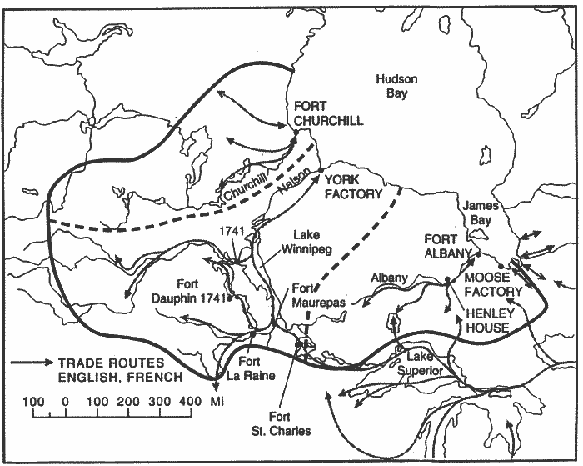
Converging in the West – What caused the competition between the French and English fur traders to come to an end in 1760?

What is Nor’Wester short for?
- What year was this company established? What did this company eventually accomplish?
- Marie-Anne Gaboury (1780-1875) was the first woman to live in . She helped to establish the presence in Western Canada.
- The Rocky Mountains were a barrier that kept the voyageurs from pushing westward.
- Alexander was one of the first Europeans to cross the continent by land from east to west.

The Impact of Contact – the fur trade resulted in many long-term changes.
Positive Impacts:

Negative Impacts

Fort Whoop-Up and the Whiskey Trade:
- What was a common trading item in 1860? .There was no force in Canada so you could do as you liked. The free traders would trade for hides.
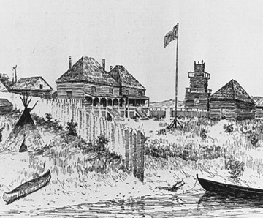
- Fort Whoop-up was built in by and . Whisky was made from many ingredients including (5 Marks) . This caused many First Nations People to become so sick that they couldn’t care for their , and some even ended up .
What new “dual heritage” culture was created? What people are considered to be a member of this group?

