CHAPTER 2
THE FRENCH IN NORTH AMERICA

What kind of society did the French colonists create in their North America Colonies?

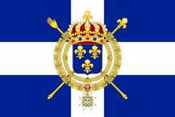

7.1.3: Students will compare and contrast diverse social and economic structures within the societies of Aboriginal, French and British peoples in pre-Confederation Canada by exploring and reflecting upon the following questions and issues:
7.1.3.3: What were the social and economic factors of European imperialism?
7.1.3.4: In what ways did European imperialism impact the social and economic structures
of Aboriginal societies?
7.1.3.5: How was European imperialism responsible for the development of Acadia, New
French and British settlements?
7.1.3.6: Who were the key figures in the French exploration and settlement of North
America?
7.1.3.7: What roles did the Royal Government and the Catholic Church play in the social
structure of New France (i.e., governor, intendant, Jesuits, religious
congregations)?

VOCABULARY

TERM | DEFINITION
Acadians

Bishop
Canadiens

Citizens
Colony
Coureurs
de bois

Empire
Governor
Habitants

Imperialism
Intendant
Monopoly

Seigneurial
System
Sovereign
Council
Norse *
(Pg.33)
Petroglyphs *
(pg. 36)

Scurvy *
(pg. 37)

Silk Road*
(pg. 33)

Trade Monopoly*
(pg. 39)

IMPERIALSIM
KEY CONCEPT:
When Europeans first came to North America, they created new settlements called colonies. A COLONY _____________________________________________________
______________________________________________________________________.
Up until the mid-1900s, many countries in Europe, Asia and the Middle East claimed colonies around the globe. The earliest colonists in Canada came from France. They are the ancestors of most Francophone Canadians today.

EMPIRES ______________________________________________________________
______________________________________________________________________Colonies had no independence, meaning that the people living in a colony did not have control of their political or economic affairs. Decisions about their future were usually made by the home country. This system of countries extending their control over other nations is called _________________. For centuries, much of the world was ruled by imperial powers. It was within this framework that Canada became a country.

How did New France get started? Fill in the flow chart using page 31 as your guide. Draw the arrows as well.
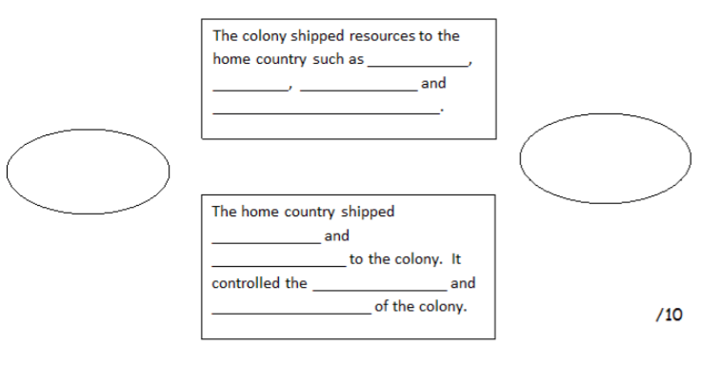

EUROPEAN IMPERIALISM

Why did the Europeans want to find a water route from Asia to Europe?
__________________________________________________________________________________________________________________________________________________________________________________________________________________
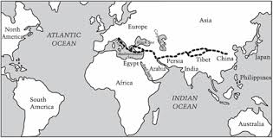

List the 4 reasons that the imperial countries of Europe wanted to expand their empires and briefly explain each one.
_____________________ | _____________________
_____________________ | _____________________
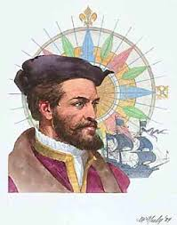
FRANCE TAKES AN INTEREST IN NORTH AMERICA

JACQUES CARTIER

- What year did Cartier set out to find a passage from North America to Asia?
_________________________________________________________________

- How many ships did Cartier sail with?
_________________________________________________________________

- Where did Cartier land after 20 days at sea?
_________________________________________________________________

- Who were the first group Cartier met (they were paddling in their canoes)?
_________________________________________________________________

- Why did Cartier sail farther up the St. Lawrence?
_________________________________________________________________

- Why did Cartier and his crew die when they tried to stay the winter near Stadacona?
_________________________________________________________________

- What was the cure for scurvy?
_________________________________________________________________

- In 1542, where did Cartier set up a colony?
_________________________________________________________________

- Read the last paragraph on page 38 of your textbook. What is the most important contribution that Cartier succeeded in?
_________________________________________________________________
_________________________________________________________________
_________________________________________________________________

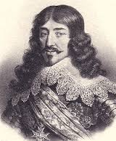
FRANCE EXPANDS ITS EMPIRE

What were the two reasons that King Louis wanted to build a colony in North America?__________________________________ ______________________________________________________________________

Why did King Louis set up trade monopolies? _________________________________
______________________________________________________________________

Who were the first French pioneers?

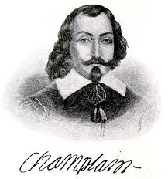
What 2 jobs did Champlain do? ______________________
________________________________________________

In 1605, where did de Monts establish a settlement?
______________________________________________________________________

What jobs did the Acadians do to survive in their new land?
____________________________________________________________________________________________________________________________________________

Later on, de Monts and Champlain started another new settlement that came from the Algonquin word meaning “the place where the river narrows”. What do we call that site today?
______________________________________________________________________

Why do you think Champlain is called the founder of New France?________________
______________________________________________________________________

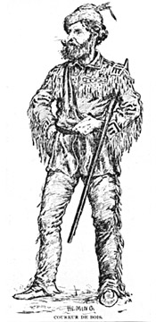
Coureurs de Bois

What does the term coureurs de bois mean in English?
___________________________________________________________

How do you know that these adventurers were VERY INTELLIGENT?
___________________________________________________________
____________________________________________________________________

Why the young French men were lured into the fur trade

How did these men help with the exploration of the new land? ___________________
______________________________________________________________________

RADISSON & GROSEILLIERS
These 2 courerurs de bois were the first men to travel to the far end of Lake Superior. Along the way they claimed land for France. In 1670 they travelled to HUDSON BAY because they were looking for __________________ animals.

The biggest accomplishment Radisson and Groseilliers had was to start a fur trading business. What was the name of their company?
______________________________________________________________________

DIFFERENT PERSPECTIVES ABOUT LAND
When people from France explored new land, what was their goal?

What did the First Nations people believe about the land and its resources?

Why did the population of New France grow very slowly?

ECONOMY & GOVERNMENT IN NEW FRANCE

What two products made France richer and richer? ____________________________
______________________________________________________________________

Since people did not want to settle in New France, King Louis XIV set up a SOVEREIGN COUNCIL to govern the colony. It was made up of three key officials. Name the 3 officials and give a brief description of their responsibilities.
- __________________________________________________________________________________________________________________________________
- __________________________________________________________________________________________________________________________________
- __________________________________________________________________________________________________________________________________

THE CATHOLIC CHURCH: the main religion of France and New France
3 groups of people who went to New France to help build the colony.
What were some of their jobs?

What was the most important goal of the church? _____________________________
______________________________________________________________________

How did the Church get money to do its work? _______________________________
_____________________________________________________________________
This is called a __________________.

What was the special order of missionaries called? __________________________
(They wrote a series of journals about their work and travels.)

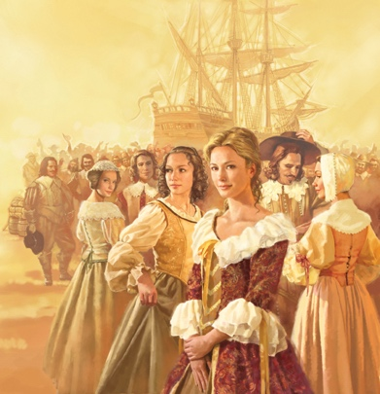
Filles du Roi

What does filles du rois mean in English? __________________
____________________________________________________

Why did the colony need women to marry the male colonists? ___________________
______________________________________________________________________

How much did the population grow in 14 years? ______________________________
______________________________________________________________________
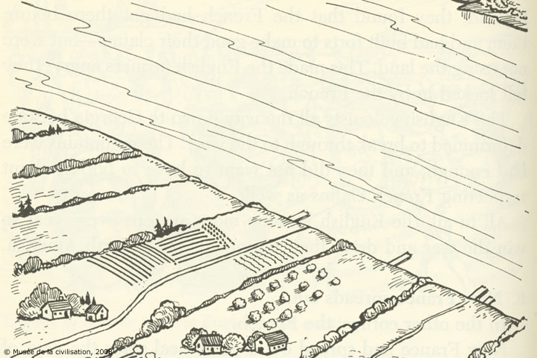

Seigneurial System

What did the king give the nobles (seigneurs)?
________________________________________
________________________________________

What did the seigneur have to do in return for the piece of land?_________________
______________________________________________________________________

Why did the habitants want to be along the St. Lawrence River? _________________
______________________________________________________________________

The seigneur and habitant had duties to each other. What did each person have to do?
Seigneur: | Habitant:

THROUGH HARD WORK
AND PESERVERANCE,
THE CITIZENS OF NEW FRANCE
LAID THE FOUNDATIONS
OF CANADA!

