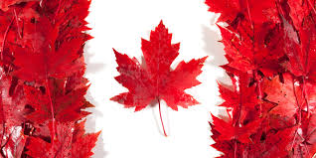
Chapter 10: Expanding Confederation
Name:
Chapter Inquiry
What factors led to British Columbia, Prince Edward Island, Alberta, Saskatchewan, and then Newfoundland to become provinces of Canada, and what were the consequences?
Vocabulary – Use the glossary or text to define the following words.
Historical Perspective
Magistrates
Responsible Government
Reserves
Residential Schools
Assimilation
Referendum

Key Concept – Historical Perspective
History is similar to your . It is the record of what has happened in the . Without history, we do not know how things came to as they are . All events have their roots in the ___________. History helps us to why things are the way they are. We call this _________________________ .
Time and Change – In this chapter we will find out how Canada gained more provinces.
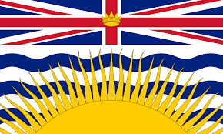
British Columbia Joins Confederation –
British Columbia was all and mountain and not suitable for . The people originally came for one thing only: !
A Gold Colony – The trade attracted the first to the Pacific Coast. By 1849, the only European was a small British colony at Fort on Vancouver Island. In the 1850s the First Nations brought , which they had mined nearby, to trade with the . Word that there was gold in the mountains spread to the outside world. Prospectors into the region and the gold was on. In 1858 about prospectors were scrambling along the banks of the River.
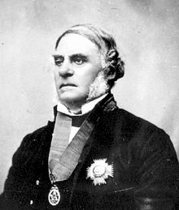
James was the Governor of British Columbia and he was as the miners flooded into the . He was also worried that the that had happened during the gold rush would also happen in Columbia. To maintain and he created a police force and appointed to enforce the . There were some violent between the miners and the First people. In the colony of British was created. Fort would be the administrative centre and they had a combined population of about people.
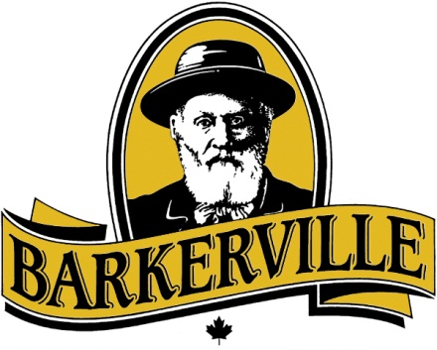
The Road to Gold – Eventually the prospectors moved further north. They finally discovered more gold along the River in the Mountains. In order to get supplies to these remote mining camps they built a road. It was called the Road and was completed in and it cost more than one dollars. Over miners made their way from New to Barkerville which was a town for the .
A New Beginning – The gold rush lasted until when Barkerville to the ground. During the gold rush, was transformed into a thriving centre. After the rush many of the newcomers stayed on. The Cariboo road was the of a network of roads. Other activities got started including . Many towns in B.C. were for people who wanted to work in the industry.
First Nations in British Columbia – There were a variety of First Nations who lived on the and of British Columbia. Governor moved the First Nations Peoples onto small . To this day they have not received any for land that was from them.
One Colony on the Pacific – On the Pacific coast, first , and then , added to Britain’s wealth. The of these colonies was important too. They provided a base for the British on the Pacific . In return Britain paid for the colonies and . This was expensive and Britain thought it too much money to run colonies so it united both colonies into called British Columbia.
The colonists in British Columbia were and they knew that something would have to they had three choices, what were they?

Confederation Achieved – In 1870 delegates from British Columbia went to to discuss joining Canada but in order to do so they wanted something in , what did they want?

Canada agreed and also offered to build a railway within years. On 20th, , British became the province of Canada.
Prince Edward Island Joins Confederation – Although P.E.I was one of the colonies that took part in the that led to Confederation in they decided to join Canada at that time.
Glue the Flag of Prince Edward Island Here
Rejecting Confederation – When they rejected Confederation in 1867 the people of P.E.I. wanted two things. What were they?
- 2.
Rethinking Confederation – What factors convinced P.E.I to change its mind?

A Better Deal – In 1873 delegates from P.E.I. went to to discuss joining Canada. As a part of the deal, Canada agreed to do the following:

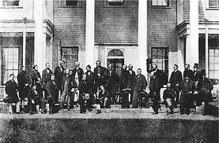
The Islanders voted in favour of joining Canada on 1st and Prince Edward Island became the province of Canada.

Two New Provinces in the West – After Prince Island and British joined Confederation, Canada stretched from to sea. But between Manitoba and the Mountains lay the - Territories. Although they were part of they were provinces.
Government for the Territories – The North-West Territories Act made the capital city. In they were granted full government and provided with seats in the of .
Provincial Status – The population was growing . The arrival of so many new was putting pressure on services such as , , railways and other services were badly needed. Unlike the colonies of B.C. and P.E.I. the North-west territories was already a part of and they wanted to become a . First they had to settle issues, what were they?

Prime Minister insisted that two provinces were better than . In the Saskatchewan Act and the Alberta Act created two new .
Glue the Flag of Alberta Here
Glue the Flag of Saskatchewan Here

Newfoundland and Confederation – and Labrador remained outside of Canada for more than years.
Economic Disaster – The economy of Newfoundland and Labrador was based on exporting , , and . During the Great Depression of the the world economy and prices for these things fell. Thousands of Newfoundlanders lost their . The colony was about to go . Things did not change until the world in 1939 when and the U.S. built bases in the colony and there were for just about everyone.
Glue the Flag of Newfoundland & Labrador Here
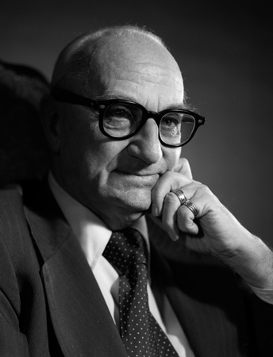
Confederation Revisited – At the end of the war Britain wanted Newfoundland to take over its own affairs once again they had three alternatives

On June 19 the people of Newfoundland voted in a about their future. On March 31st Newfoundland and became the province of Canada.
The Consequences of Confederation – The people of Newfoundland gained access to Canada’s programs including insurance, health and old age . In the 1950’s Premier brought electric to the rural areas and expanded the mines in Labrador. By 1965 the - stretched across the province. Things did not remain as good as they had been. The industry Limitations were placed on the hunt.

