Happy Birthday Canada!
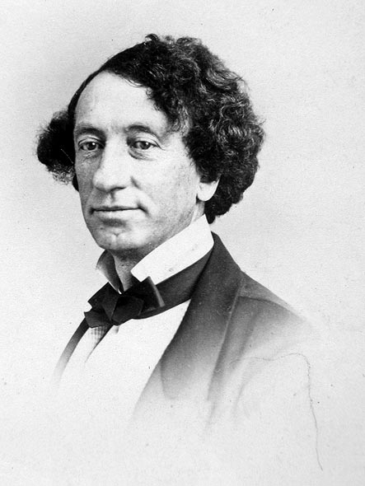
To celebrate Confederation you will design a birthday invitation or birth announcement for Canada. You will be responsible for including the following information:
- July 1, 1867
- Nova Scotia, Ontario, Quebec, New Brunswick (NOQN)
- Prime Minister John A Macdonald - Father of Confederation
- “Kanata”- The Haudenosaunee word for village
- Symbols of Canada- beaver, Maple Leaf Flag
- The Words to O’Canada
Be as creative as possible, put in a good effort, make your work neat and colourful. Remember that this is a celebration of the birth of a new country . . . . . . . Have some fun with this project!!!
You will be marked using the following rubric:
 | 5 - Outstanding | 4 - Proficient | 3 - Basic | 1 - Limited
Historical Thinking | Includes broad, detailed content from the History of Canada | Includes credible content from the History of Canada | Includes surface and cursory content from the History of Canada | Includes vague, partial or incorrect content from the History of Canada
Visual and Written Literacy | Presents in a creative, engaging way, using care and putting forth a great deal of effort | Presents in a credible, interesting way with good use of care and effort | Presents in a logical, clear way, is lacking care and effort | Presents in a confusing or incorrect way, is incomplete, lacks care and effort
Total Score
/ 10

