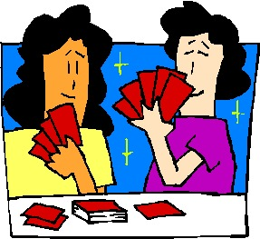
CARD GAME REVIEW
You have been given the assignment of creating a card game that can be used as a review tool for your classmates.

For this assignment you must choose a partner and together work to create a social studies card game that your classmates will be able to play. This game must include the following:
- At least 20 questions that cover material from Chapter 6: Becoming Canada. The information on the cards must be accurate and contain details that are relevant to the topic. You may not use the same people or event on more than one card.
- A set of rules that explains how the game is to be played. Think about specific details (how many people can play, when to take your turn, how to score points)
- Your cards must be legible and visually pleasing. Take your time so that this card game can be played by others and used as a review tool. Make sure that visuals are relevant to the topic being discussed (although flowers are pretty is this related to the building of Canada?)
You will be marked based on the following:
CRITERIA | 4 | 3 | 2 | 1
Accuracy/Content & Knowledge (x3) | All information & content is accurate and contains all information relevant to the topic. Game includes at least 20 different questions. | Almost all information & content is accurate but some relevant information is missing. Game only has 15-19 questions. | Some of the information & content is accurate but relevant information is missing. Game only has 10-15 questions. | Information & content is not accurate information on cards is not relevant. Game has less than 10 questions.
Legibility & Visuals | Information is well organized and easy to read. Cards are well put together and visuals are relevant. | Information is somewhat organized and mostly easy to read. Some visuals are not relevant. | Information is unorganized and difficult to read. There is a lack of visuals. | Unable to comprehend information and no visuals included.
RULES | Rules were written clearly enough that all participants could easily play. | Rules were written, but one part of the game needed slightly more explanation. | Rules were written, but participants had some difficulty figuring out the game. | The rules were not written.

TOTAL: /20

